**Monday Morning Meetings at Woodburn**

Monday Morning Meetings will be hosted on a full grade level link in Blackboard 24-7. This is different from their classroom link they received in Gmail. The purpose is to allow for community building among the grade level and for students to work with other adults in that time. Please follow these directions for accessing Monday Morning Meetings!

**Step 1: Log into Blackboard**

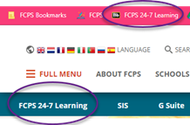                       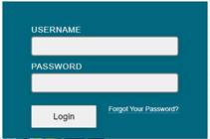

**Step 2: Click on your grade level course**



**Step 3: Click on “Monday Morning Meeting”**

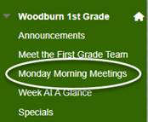

**Step 4: Join session!**

