Kindergarten Newsletter January 2020
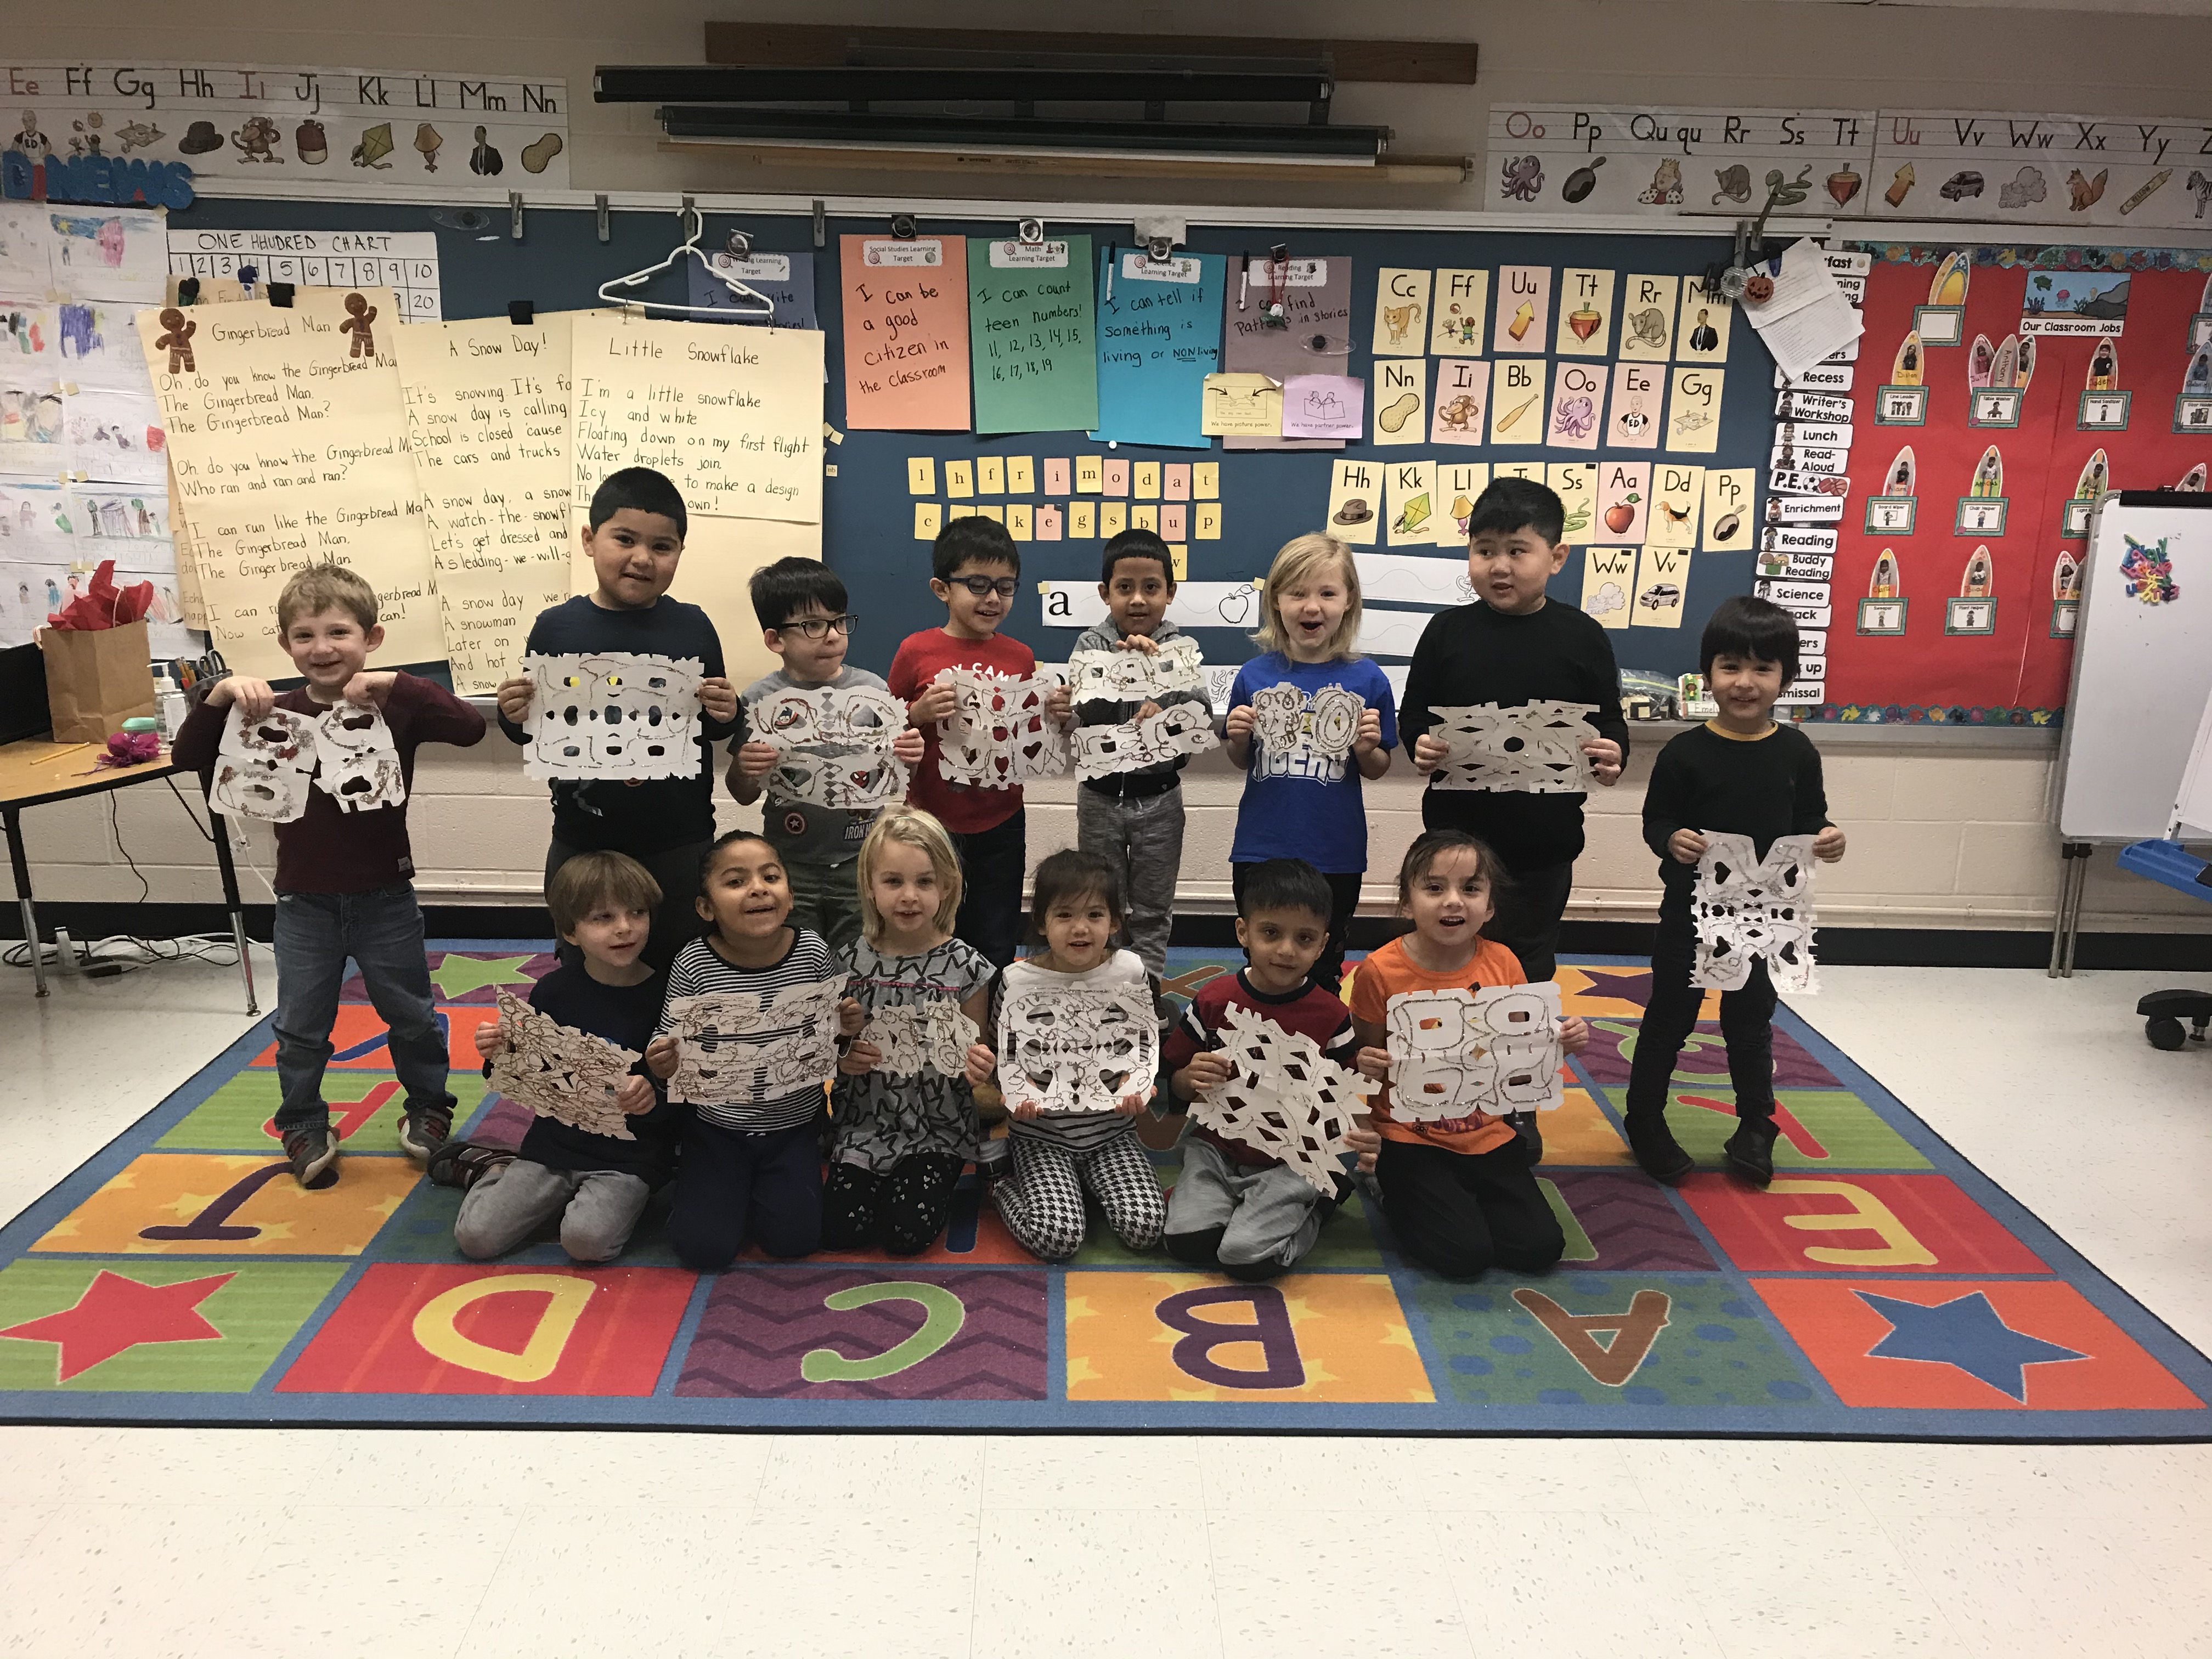

Reminders:
- Change of clothes should be kept in your child’s backpack
- A healthy snack every day
- Appropriate bed time

Upcoming Events:
January 20th-Student holiday
January 27th and 28th-Student holiday

What Are We Learning?
Reading
Our kindergarten students will be completing their study of patterns in books. Next, we will be exploring non-fiction

Writing
The students will continue working on writing and illustrating pattern books.

Math-
Students will be diving into composing and decomposing numbers.
Science
Our students will be discovering how things change over time.

Social Studies-
Our Kindergarten students will be learning about maps and globes and how they help us in our communities.

The Kindergarten Team appreciates all your support!

