
Fourth Grade Newsletter
December 2019
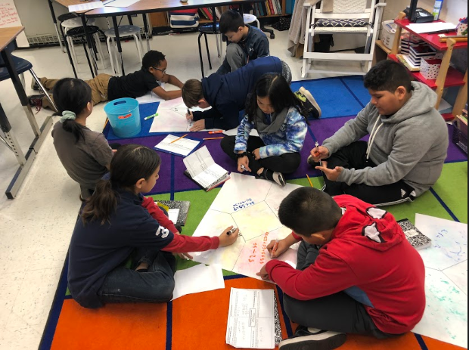

Reminders
If there are any changes to your child's schedule, please email your child's teacher AND TimberLaneES.Attendance@fcps.edu. Use this email if your child will be late, absent, or needs to go home early. Also, use this email for changes in transportation or if someone else will pick up or meet your child. Dismissal changes MUST be emailed before 2:30 pm.

Upcoming Events:
December 23- January 6 - Winter Break
January 20- Martin Luther King Jr.’s Birthday- No School
January 24- End of the 2nd Quarter
January 27 & 28- No School
What We Are Learning
Reading/Writing: This month we have been reading nonfiction and narrative nonfiction texts. In order to learn from these texts, readers synthesize and develop their theories and opinions to understand the world. To help support your child at home, ask them to discuss what they already know about the topic and what they might learn before they begin reading a nonfiction text. During and after reading nonfiction readers consider what they have learned from the text as well as determining the author’s message.
In writing have been focusing on featured articles. We have been learning about how writers plan and organize their knowledge about a nonfiction topic to help readers develop an understanding of the topic. We also have been working on identifying prefixes and suffixes in words. To support your student at home, have your student to find a word in their book that has a prefix or suffix, and ask your student to identify the prefix or suffix of the word and what it means.
Math: This month we developing an understanding of decimals. We are learning how to represent, add, subtract and count by decimals to thousandths. We are also learning how to identify equivalent decimals and fractions. To support your student at home, give them a decimal number, up to the thousandths place and ask your student to read the number and identify each place value. Test Date January 31st. Please also continue to work with your child to develop efficient strategies to learn their multiplication and division facts!
We are also continuing to be familiar with multiplication and division facts and apply strategies to multiply two whole numbers (1 digit × 1 digit and 1 digit × 2 digits) and divide two whole numbers (one-digit divisor and two-digit dividend), with and without remainders.
Advanced Math: This month we finished our unit whole number computation and began our unit on decimal computation. Students have been working on adding and subtracting decimals (through thousandths), creating and solving single and multistep practical problems involving addition and subtraction of decimals, and using estimation as a means for checking for reasonableness when computing with decimals. Our next unit will be on adding and subtracting fractions with denominators of 12 and below. Please continue to work with your child to develop efficient strategies to learn their multiplication and division facts!
Science: We have started our Weather and Beyond unit. We will also be learning about weather phenomena, the organization of the solar system, the characteristics of the Earth-moon-sun system, how scale models can be used to study the solar system, the cause of changing moon phases and seasons on Earth, and how to record and study weather data
Social Studies: Our next social studies unit will be focused on the Revolutionary War. We will be learning the reasons why the colonists went to war with Great Britain, the Declaration of Independence, and identifying the various roles of American Indians, whites, enslaved African Americans, and free African Americans including George Washington, Thomas Jefferson, Patrick Henry, the Marquis de Lafayette, and James Lafayette.
Advanced Academics: We will be starting Caesar’s English, a vocabulary program introduces students to the concept of Latin stems as the foundation for English academic language. Learning the meanings of the stems allows children to figure out the meanings of many other words that contain those same stems.
Positivity Project: This month we focused on the following character traits: Optimism, Prudence, Perseverance and Supporting others when they struggle.

