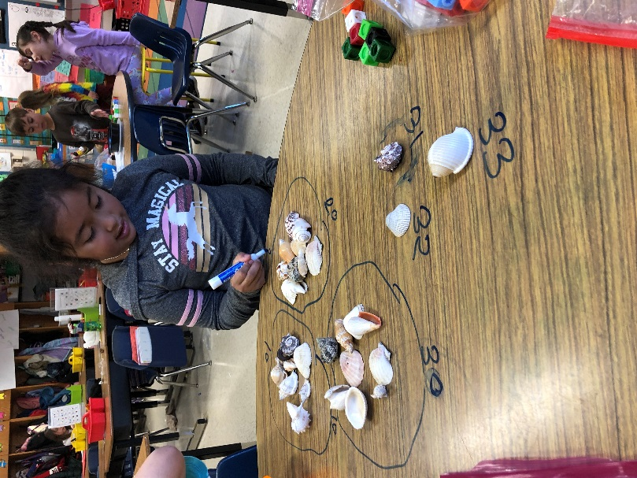
First Grade Newsletter January 2020



Reminders:
*Please check yellow folders on Wednesday afternoons and return yellow folders on Thursday morning! Thank you!
* If there are any changes to your child's schedule, please email your child's teacher AND TimberLaneES.Attendance@fcps.edu. Use this email if your child will be late, absent, or needs to go home early. Also, use this email for changes in transportation or if someone else will pick up or meet your child. Dismissal changes MUST be emailed before 2:30 pm.
At Home Teaching:
*Please read with your child for 20 minutes every night. When students are solving a word, you can remind them to use the picture, get a running start, or look for parts they know. When you finish reading, ask your child about their favorite part and WHY.
*You can also practice math concepts by placing objects into groups and have them count by 2, 5, or 10. To improve an understanding of place value, call out a number from 10-99 and have your child identify the tens and ones. For example, 79 has 7 tens and 9 ones.
Upcoming Events:
January 20: NO SCHOOL
January 24: End of 2nd Quarter
January 27-28: NO SCHOOL
What Are We Learning?
Reading: We are continuing our Non-Fiction Unit. Students are learning about how to think and talk about information from non-fiction books. Students are using nonfiction text features to make predictions, find something interesting to share, and reading with feeling
Writing: We are continuing our Non-Fiction Unit and writing How-To books. Students are using words and pictures to teach others about something they know how to do.

Math: We are continuing our Place Value and Number Sense Unit. Students are learning to use tens and ones to identify the value and compare different numbers. We are practicing estimation and magnitude. Students are practicing counting in efficient ways (by 2’s, 5’s, and 10’s) up to 120.

Science: We will continue learning about sound and early chemistry concepts such as mixing and dissolving.

Social Studies: We will begin learning about maps and how to locate places. We will also learn about economic concepts such as the difference between goods and services and producers and consumers.

Health: We will be making goals for the New Year.

