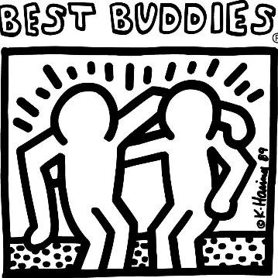

Show your support for the Franklin MS chapter of

Best Buddies by purchasing a t-shirt!

Best Buddies International is a nonprofit 501(c)(3) organization dedicated to establishing a global volunteer movement that creates opportunities for one-to-one friendships, integrated employment, leadership development, and inclusive living for individuals with intellectual and developmental disabilities (IDD)

**T-shirts are $13.00 each. Cash or checks are accepted. Make checks payable to: Franklin Middle School ( put “*Best Buddies”* on the memo line). Please return this form with your payment to Mrs. Dryer Room 110 or Ms. Hills room 109A by January 31st.**



Please write the quantity wanted next to the size

XS____ S____ M____ L____ XL____

Total Shirts Ordered_____

Total Due: $_____