Franklin Middle School
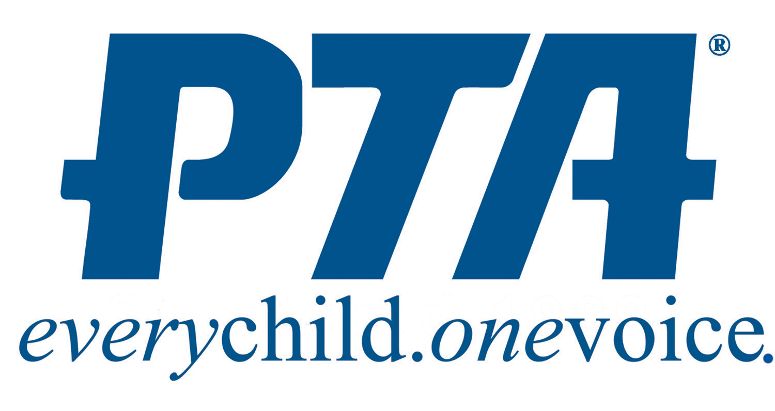

2019-2020 Executive Board and Committee Chairs
Executive Board:
President | Heather Noiwan | heathernoiwan@gmail.com  703-851-5534  Student: Marley, 8th
7th Grade Vice President | Marta Szotakova | marta@galysh.us  703-577-9862  Student: Anna, 7th
8th Grade Vice President | Vacant
Secretary | Jill Thurber | jillcthurber@gmail.com  703-943-6427  Student: Ryan, 7th
Treasurer | Karen Ethridge | karendethridge@gmail.com  256-457-8864  Student: Samuel, 7th

Committee Chairs:

Social Media/Communications | Puja Siegman | pujab76@yahoo.com  571-278-8898  Student: Devyn, 7th
Hospitality | Lisa Yonkers | lisayonkers@gmail.com  703-408-2899  Student: Alexis, 7th
NJHS Liaison | Mallika Padala | oaktonkids@gmail.com  571-225-7575  Students: Vinisha & Omiisha Cheella
Dining for Dollars | Heidi Zimmerman | heidizimm06@gmail.com  703-304-3410  Student: Bailey, 7th
Membership | Vacant
Spirit Wear | Vacant
8th Grade Party | Vacant
7th Grade Party | Vacant

Updated as of 10/4/2019

