MODELL’S SPORTING GOODS
COUPON FUNDRAISER
*Save 15% off your total purchase!
*Earn rewards for your school
*Earn Awards point MVP while supporting your school.
-When you check out the cashier has a bar code for your school. So mention Saratoga Elementary School for your discount and credit for
Saratoga.
-Dates of fundraiser are 2/8-3/7.
-This discount is good at any MD/DC/VA Modell locations.
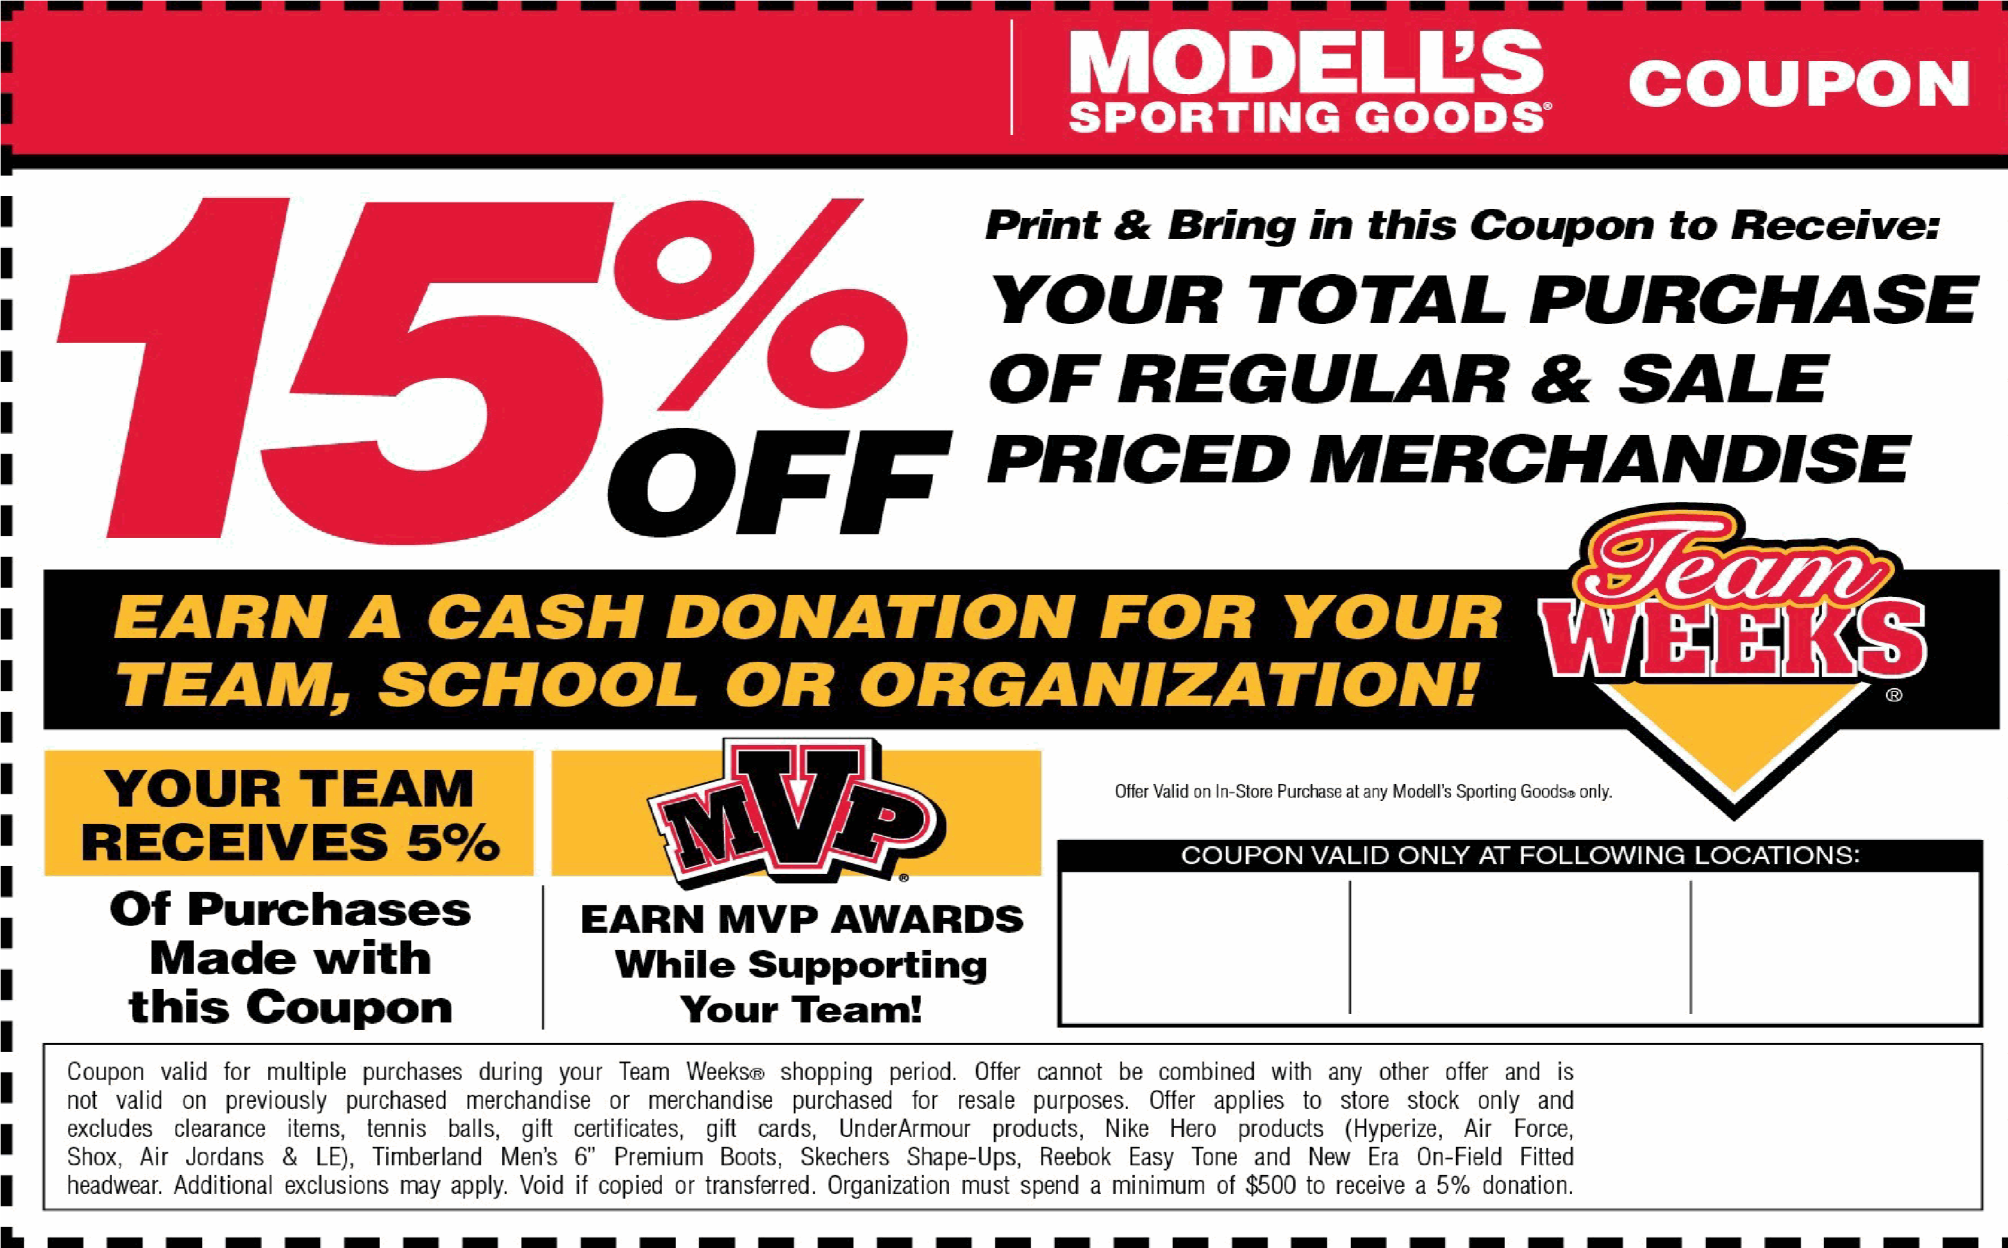
Saratoga Elementary School PTA
dc md va
dc md va
dc md va
2
/8/2019-

3
/7/2019
Valid From:
U(a59002*LTSOKq(v

