
Contact the PTA
washingtonmillpta@yahoo.com

Website: https://washingtonmillpta.ptboard.com
Washington Mill Elementary
9100 Cherrytree Drive,
Alexandria, Virginia 22309
WMES PTA NEWS YOU CHOOSE



PTA Board
President – Emily Lussier
VP – Jennifer McDonald
2nd VP – Tashua Kurtzals
Treasurer – Kevin Payne
Rec. Secretary – Jessica Rosado
Cor. Secretary – Jennifer Roca
Like us on Facebook: Washington Mill PTA
Follow us on Twitter: @WashMill_PTA

Are you receiving the weekly news via email from Washington Mill Elementary and the PTA? If not, please check the following things: Is it in your Spam Folder? Have you signed up for it? Is your email address correct?

It is easy to sign up for News You Choose. Go to https://washingtonmilles.fcps.edu/ and scroll down to the yellow box and click Sign Up Now:
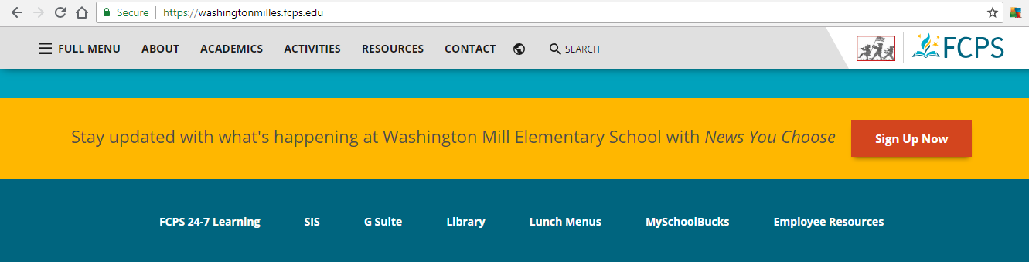


Enter your email address and create a password. Then simply subscribe to Washington Mill Elementary School. It is that easy!
Select PTA under the Subscriptions Topics

