 | 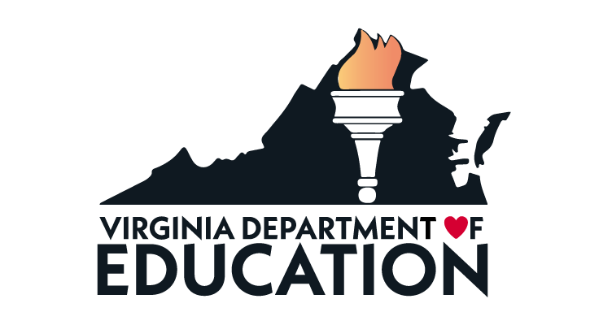

Please join us for the WIDA Early Years Webinar!

The Virginia Department of Education partnered with WIDA Early Years to help support multilingual children in early care and education (ECE) settings. As a key stakeholder in the care and education of this population of children, we invite you to join us for the Virginia and WIDA Early Years, Let’s talk about language: Language-Focused Approaches to Engaging with Families of Multilingual Children.
This event introduces participants to language-focused family engagement.
This unique approach to family engagement centers firmly on multilingual children and their families by drawing attention to language learning and development that occurs both in-and out of early care and education settings. Participants will explore findings and recommendations from research with parents of multilingual children ages 0-5 and have opportunities to discuss connections to local family engagement policies and practices.

Event Objectives
- Raise awareness about the need for language-focused family engagement

- Initiate critical reflection on opportunities to integrate language education and family engagement

- Generate ideas for action in local settings

Use the links below to register for the upcoming webinar:

Wednesday, September 14, 2022, 3:00-4:00pm EST
REGISTRATION LINK

If you have questions about the event, please contact Rebecca Shaffer at Rebecca.Shaffer@doe.virginia.gov.

