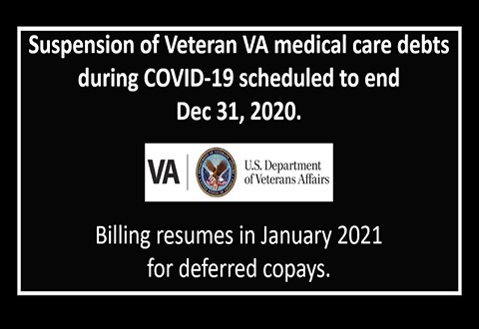

Suspension of Veteran VA medical care debts during COVID-19 scheduled to end in December
Veterans should be aware and plan accordingly that the current suspension of VA collection actions and extension of terms of previous repayment agreements is scheduled to end December 31, 2020.
VA stopped sending monthly billing statements for medical care debt starting April 6, 2020. This change followed the President’s April 2 announcement that was part of the nation's relief response to the COVID-19 pandemic. In addition, all actions on debts owed to VA in the form of copayments under the jurisdiction of the U.S. Department of Treasury were suspended.
With the conclusion of the mandated deferral, VA plans to begin billing Veterans in January 2021 for those postponed copays.
In January, Veterans should receive a patient statement that includes new copay charges for any care or prescriptions from April 6, 2020, through December 31, 2020, and any unpaid copays from before April 2020.
Veterans are not required to make payments until after December, but they can make them now if they want.

How do I pay my VA copay bill?
Veterans can pay their bill in any of these 4 ways:

Online
Pay directly from your bank account or by debit or credit card on the secure Pay.gov website.

By phone
Call the VA at 888-827-4817. Be sure to have your account number ready.

By mail
Send your payment stub, along with a check or money order made payable to "VA," to the address below. Be sure to include your account number on the check or money order.

VA San Diego Healthcare System
3350 La Jolla Village Drive
Attn: WCPAC
San Diego, CA 92161

In person
Visit your nearest VA medical center and ask for the “agent cashier's office.” Bring your payment stub, along with a check or money order made payable to “VA.” Be sure to include your account number on the check or money order.
The agent cashier can look up your billing information; just bring a photo ID card.

Agent Cashier
(858) 642-3449
VA San Diego Healthcare System
3350 La Jolla Village Drive
San Diego, CA 92161
Room 1509. Monday – Friday 8:30 am – 4:00 pm

