COPD  CLASSES  FOR VETERANS & FAMILIES  When  EVERY 3RD THURSDAY  1:00 PM – 3:00 PM  Where  OCOTILLO CLINIC CONFERENCE ROOM  BENEFITS · Increase your knowledge of managing COPD · Early identification of symptoms · Improve your Quality of Life · Ask questions of Clinical Specialists · Peer Support · | cLASSES INCLUDES:  copd  *Overview of Disease  *Causes  *Symptoms  *Treatments  Healthy eating  *Nutritional Risks  *Tips to Improve Healthy Eating Choices  *Resources Available  Activity & Relaxation  *Exercises  *Energy Management  *Breathing Tips  *Stress Management  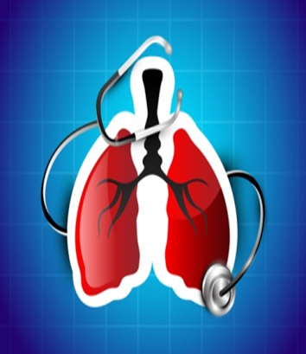  ASK YOUR PACT TEAM FOR MORE INFORMATION

