Guidance for New Email Signature Block for ORMDI Staff

Font: Arial 11
Left Justify
Line space: 1.0

Name (in Bold and Arial 12)
Position Title
Address
Office of Resolution Management, Diversity & Inclusion
[City, State Zip Code]
Telephone numbers (Office first, followed by (O); Cell second, followed by (C), fax third, if necessary. Area codes should be inside parentheses; all phone numbers should be separated by a space, a forward slash (/) and another space [(xxx) xxx-xxx / (xxx) xxx-xxx]

Beneath the phone numbers, insert the following logo, core values and core characteristics followed by the telework notice and survey request:

VA Core Values: Integrity Commitment Advocacy Respect Excellence
VA Core Characteristics: Trustworthy | Accessible | Quality | Innovative | Agile | Integrated

[Personal message, if any, is placed here]

NOTICE: ORMDI is operating in a 100% telework environment. ORMDI does not have the capability to send and/or receive hardcopy documents at this time. In order to be more responsive, we ask that if you have previously sent documents to us via U.S. Mail or other delivery services, please resend those documents to us electronically. All meetings, interviews, and mediation sessions will be conducted in a virtual capacity (i.e. telephonic, skype, video conference etc.). Your patience is appreciated during the COVID-19 Pandemic.
Thank you for contacting the Office of Resolution Management, Diversity & Inclusion. Our goal is to provide you with exceptional customer service. Please take a moment to complete a very brief survey to let us know how my service was today.

Image of the VA logo should be left justified.
Teleworking Notice and survey request: Arial 9, Italics

Instructions for editing your signature block (see next 2 pages):

In Outlook, click on “File,” “Options,”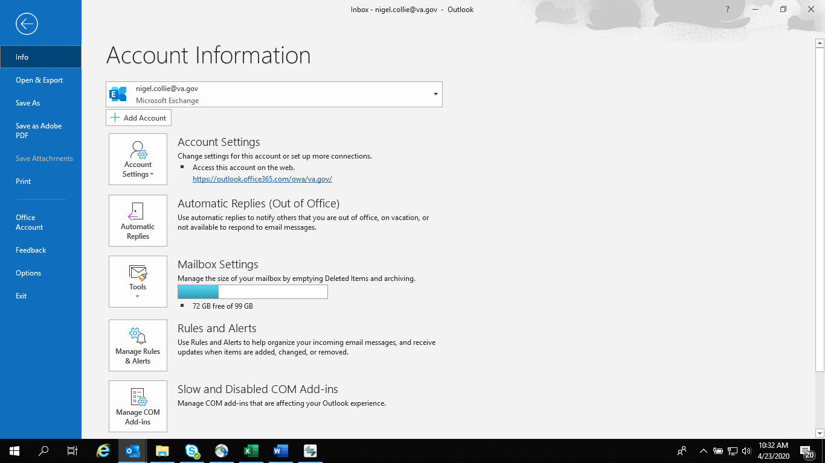

“Mail.”

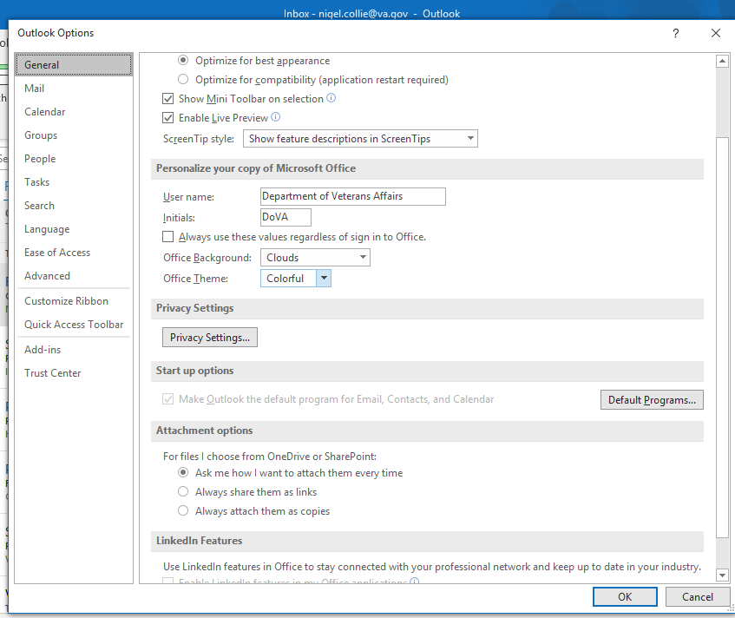

In the pop-up box, click on “Signatures….” found on the right side of the screen.

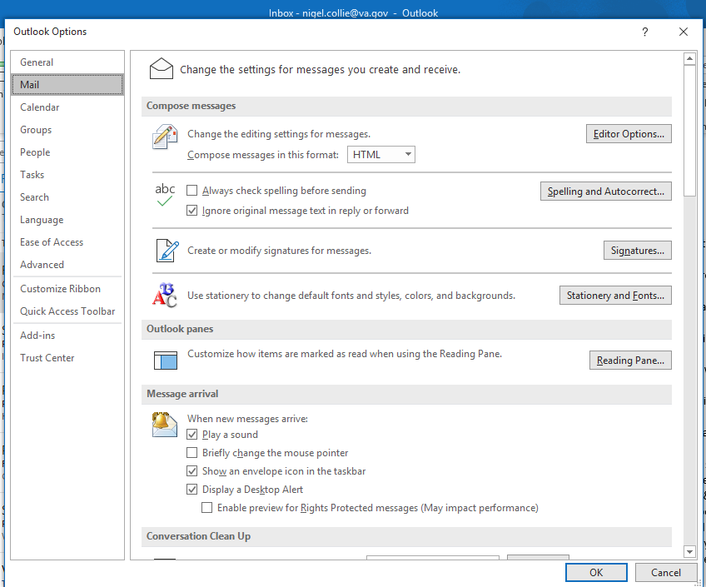

To edit your existing signature, enter the “Edit signature” box, make your edits (make sure you have selected Arial 11 as the font – the font selector is just below the Edit signature label), and then click “OK.”

