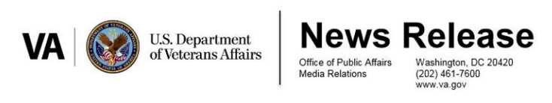

FOR IMMEDIATE RELEASE

May 31, 2017

SECRETARY SHULKIN DELIVERS HIS FIRST ‘STATE OF THE VA’ ADDRESS

WASHINGTON — Secretary of Veterans Affairs Dr. David Shulkin delivered his first “State of the VA” address today, highlighting the activity and direction of the agency since his appointment in February. In his address, Secretary Shulkin stated that he wanted to update Veterans on the progress the agency is making while also acknowledging the shortcomings that the VA has identified and will address in the upcoming months.

“As a physician, I tend to look at things in terms of the way I was trained- assess, diagnose, and then aggressively treat the patient. Though we are taking immediate and decisive steps, we are still in critical condition and require intensive care.” said Dr. Shulkin.

The address covered a wide spectrum of issues within the VA, including Access to Care, Community Care and Choice, Accountability, and the quality of care provided to Veterans. Dr. Shulkin identified multiple priorities, such as reducing backlogs and getting more Veterans access to mental health care and suicide prevention programs.

Addressing improvements in accountability and VA administration, Dr. Shulkin stated that while he was able to initiate the Executive Order establishing the Accountability and Whistleblower Protection signed by President Trump, “further legislation is needed and needed now.”

The goal, the Secretary said, is to “turn the VA into the organization Veterans and their families deserve, and one that America can take pride in.”

A fact sheet highlighting some of the elements of Dr. Shulkin’s address as well as the text of his address can be found at: http://www.blogs.va.gov/VAntage/wp-content/uploads/2017/05/StateofVA_FactSheet_5-31-2017.pdf

###

