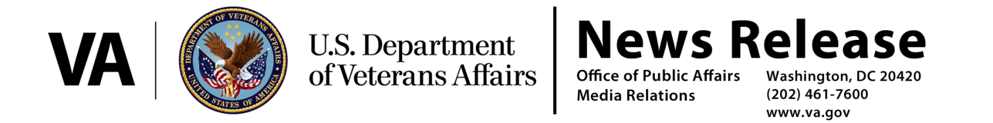
FOR IMMEDIATE RELEASE
March 14, 2017

VA’s Rule Establishes a Presumption of Service Connection for Diseases Associated with Exposure to Contaminants in the Water Supply at Camp Lejeune
VA to provide disability benefits for related diseases

WASHINGTON – The Department of Veterans Affairs (VA) regulations to establish presumptions for the service connection of eight diseases associated with exposure to contaminants in the water supply at Camp Lejeune, N.C. are effective as of today.

“Establishing these presumptions is a demonstration of our commitment to care for those who have served our Nation and have been exposed to harm as a result of that service,” said Secretary of Veterans Affairs, Dr. David J. Shulkin. “The Camp Lejeune presumptions will make it easier for those Veterans to receive the care and benefits they earned.”

The presumption of service connection applies to active duty, reserve and National Guard members who served at Camp Lejeune for a minimum of 30 days (cumulative) between August 1, 1953 and December 31, 1987, and are diagnosed with any of the following conditions:

• adult leukemia
• aplastic anemia and other myelodysplastic syndromes
• bladder cancer
• kidney cancer
• liver cancer
• multiple myeloma
• non-Hodgkin’s lymphoma
• Parkinson’s disease

The area included in this presumption is all of Camp Lejeune and MCAS New River, including satellite camps and housing areas.

This presumption complements the health care already provided for 15 illnesses or conditions as part of the Honoring America’s Veterans and Caring for Camp Lejeune Families Act of 2012. The Camp Lejeune Act requires VA to provide health care to Veterans who served at Camp Lejeune, and to reimburse family members, or pay providers, for medical expenses for those who resided there for not fewer than 30 days between August 1, 1953 and December 31, 1987.

###

