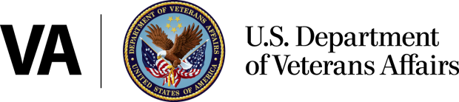

Office of Public Affairs

Media Relations

Washington, DC 20420

(202) 461-7600

www.va.gov

**News Release**

**FOR IMMEDIATE RELEASE**

**January 19, 2017**

**VA to Provide Fertility Counseling and Treatment**

**for Certain Veterans and Spouses**

WASHINGTON - The Department of Veterans Affairs (VA) announced today that it is amending its regulation regarding fertility counseling and treatment available to eligible Veterans and spouses. VA currently provides certain infertility services other than in vitro fertilization (IVF) services to Veterans as part of the medical benefits package. This interim final rule authorizes IVF for a Veteran with a service-connected disability that results in the inability of the Veteran to procreate without the use of fertility treatment. It also states that VA may provide fertility counseling and treatment using assisted reproductive technologies (ART), including IVF, to a spouse of a Veteran with a service-connected disability that results in the inability of the Veteran to procreate without the use of fertility treatment.

“I have always believed that one of the main responsibilities of a grateful nation is to make whole the men and women who have made sacrifices on our behalf,” said VA Secretary Bob McDonald. “It is important that we fully understand the needs of our Veteran population, and incorporate the major scientific advances available today that can allow them to live a full life. **Providing fertility counseling and treatment, including in vitro fertilization, is consistent with VA’s goal of restoring reproductive capabilities of Veterans and improving the quality of their lives.”**

**As part of the medical benefits package, VA provides many different types of fertility treatments and procedures to Veterans. These include infertility counseling, laboratory blood testing, surgical correction of structural pathology, reversal of a vasectomy or tubal ligation, medication, and various other diagnostic studies or treatments and procedures**

**Full implementation of this regulation requires that VA utilize and optimize existing capabilities for care in the community and develop internal processes that will provide Veterans with a seamless path to receiving ART services. Veterans can immediately schedule appointments with their local health care system for eligibility determinations, clinical evaluation and consultation, and initial treatment as we work to build this structure.**

**The interim final rule was published in the Federal Register on January 19, 2017 and can be accessed** [here](https://www.federalregister.gov/documents/2017/01/19/2017-00280/fertility-counseling-and-treatment-for-certain-veterans-and-spouses)**.**  Although the interim rule references September 30, 2017 as the date the funding expires, the funds are authorized through September 30, 2018.

**###**