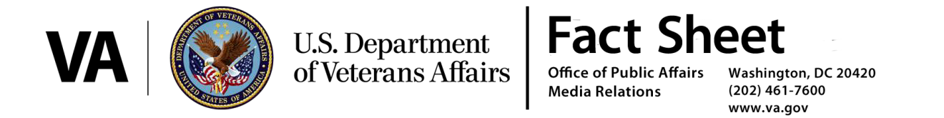
Patient Access Progress Update
Release 61 – January 12, 2017
Summary
In keeping with the commitment to improve transparency in the Department of Veterans Affairs’ (VA) processes and in accordance with Section 206 of the Veterans Access, Choice, and Accountability Act of 2014 (VACAA), VA today released the latest update of facility-level patient access data and is highlighting notable access improvements. In this release, VA is providing one report:

- Pending Appointments (Snapshot of Data on January 1, 2017)*

Notable Improvements:
- Between June 1, 2014, and January 1, 2017, the electronic wait list (EWL) went from 56,271 appointments to 26,990 a 52 percent reduction.
- When compared to the January 1, 2016 pending appointments data set, the January 1, 2017 pending appointment data set shows VA has increased the number of overall pending appointments by 1,456,526 while decreasing the number of pending appointments greater than 30 days by 4 percent.
- VHA and the Choice contractors created over 3.5 million authorizations for Veterans to receive care in the private sector from November 1, 2015 through October 31, 2016. This represents a 27 percent increase in authorizations when compared to the same period in 2014/2015.

