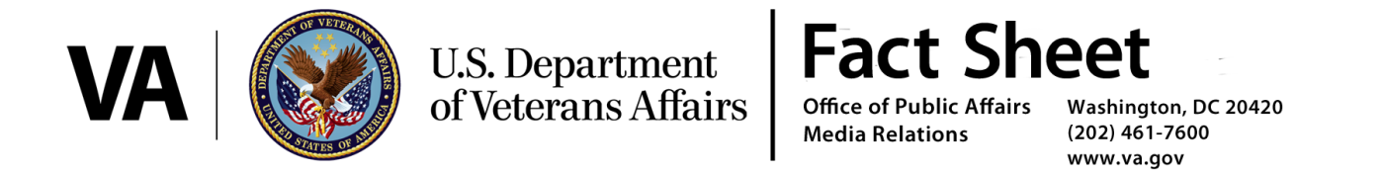
January 13, 2017
VA’s Final Rule to Consider Certain Diseases Associated with Exposure to Contaminants in the Water Supply at Camp Lejeune as Presumptive for
Service Connection

As part of the Department of Veterans Affairs’ ongoing commitment to provide care to Veterans, the VA today published regulations to establish a presumption of service connection for eight conditions associated with exposure to contaminants in the water supply at Camp Lejeune.

The rule will become effective either 60 days after publication in the Federal Register, or following conclusion of the 60-day Congressional Review, whichever is later.

Based on evidence from several internationally recognized scientific authorities, including the National Academies of Science, the Secretary of Veterans Affairs determined there is sufficient scientific and medical evidence available to establish a presumption of service connection between exposure to contaminants in the water supply at Camp Lejeune and the occurrence of eight health conditions.

The eight presumptive diseases are:

- adult leukemia
- aplastic anemia and other myelodysplastic syndromes
- bladder cancer
- kidney cancer
- liver cancer
- multiple myeloma
- non-Hodgkin’s lymphoma
- Parkinson’s disease

VA will not limit entitlement to active duty military. Rather, VA will also presume exposure for reserve and National Guard members who served at Camp Lejeune for at least 30 days (cumulative), between August 1, 1953 and December 31, 1987.

In addition, VA will establish a presumption that members of the reserves and the National Guard who served at Camp Lejeune during this period and later develop one of the presumptive diseases became disabled during the relevant period of service for purposes of establishing active military service for benefit purposes.

Presumptive service connection for a disease alleged to have been caused by contaminants in the water supply at Camp Lejeune requires medical evidence of a current disease on the presumptive list and evidence from military records or other official service department records of service at Camp Lejeune during the period of contamination. Veterans meeting these criteria should file a VA Form 21-526EZ with information showing that they have a current diagnosis and their service information. Veterans Service Organizations can help file for benefits. Veterans can also file a claim electronically through eBenefits. State on your application that your claim is presumptive due to service at Camp Lejeune.

