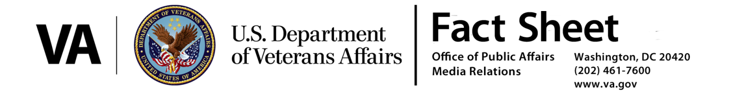
September 9, 2016
VA’s Proposed Rule to Consider Certain Diseases Associated with Exposure to Contaminants in the Water Supply at Camp Lejeune as Presumptive for
Service Connection

As part of VA’s ongoing commitment to provide care to Veterans and their families, the Department of Veterans Affairs today proposed to amend its regulations to establish presumption of service connection for eight conditions associated with exposure to contaminants in the water supply at Camp Lejeune.

Based on evidence from several internationally recognized scientific authorities, including the National Academies of Sciences, the Secretary of Veterans Affairs has decided there is sufficient scientific and medical evidence available to establish a presumption of connection between exposure to contaminants in the water supply at Camp Lejeune and the occurrence of eight health conditions, as recommended by the VA Technical Workgroup (TWG).

The proposed eight presumptive diseases are:
- adult leukemia
- aplastic anemia and other myelodysplastic syndromes
- bladder cancer
- kidney cancer
- liver cancer
- multiple myeloma
- non-Hodgkin’s lymphoma
- Parkinson’s disease

VA will not limit entitlement to active duty military personnel. Rather, VA proposes to presume exposure for all active duty, reserve and National Guard personnel who served at Camp Lejeune for no less than 30 cumulative days from August 1, 1953, through December 31, 1987.

In addition, VA proposes to establish a presumption that individuals who served at Camp Lejeune during this period and later developed one of the presumptive diseases were disabled during the relevant period of service, thus establishing active military service for benefit purposes.

VA evaluates each Camp Lejeune claim based on its individual merits. Presumptive service connection for a disease alleged to have been caused by contaminants in the water supply at Camp Lejeune requires medical evidence of a current disease on the presumptive list and evidence by official military records of no less than 30 days of service at Camp Lejeune during the period of contamination. Veterans meeting these criteria should file a VA Form 21-526EZ with information showing that they have a current diagnosis and their service information. Veterans Service Organizations can help Veterans file for benefits, or they can file a claim electronically through eBenefits. Indicate on your form that your claim is presumptive due to service at Camp Lejeune.

VA acknowledges that current science establishes a link between exposure to certain chemicals found in the water supply at Camp Lejeune and later development of one of the proposed presumptive conditions. However, VA experts agree that there is no scientific underpinning to support a specific minimum exposure level for any of the conditions. Therefore, VA welcomes comments on the 30-day minimum service requirement and will consider other practical alternatives when drafting the final rule. VA also notes that the proposed 30-day requirement serves to establish eligibility for service connection on a presumptive basis; nothing in this proposed regulation prohibits consideration of service connection on a non-presumptive basis.

For more information go to www.regulations.gov. The 30 day public comment period will be open until Oct. 10, 2016.

