Communiqué InterActive Solutions, Inc. (www.text2u.com)

TextStreaming (Secure, Internet C.A.R.T.) with Live Chat Quick Launch Instructions

RECOMMEND BROWSER: INTERNET EXPLORER
Please ensure your JAVA is current and disable your Screen Saver during Access.

Event Title: ALL VR Call
Event Link:
http://www.speche.com/EvtCart/ViewCART.aspx?Org=62035696g352327023

At least 15 minutes prior to a meeting’s start time, launch the active Event Link above or copy and paste ALL of the Link in your browser’s address bar to navigate to the Communiqué C.A.R.T. Listing Page where you will Enter your First Name in the “Viewer” box and click on JOIN next to the Event Title.

As the TextStreaming Display Room loads, ACCEPT any Security/Trust Certificates.
The TextStreaming Display Room will state “Welcome to (your event title)” in the upper left corner. Please type into the Chat Box on the right side of the display, your Full Name, Organization and Location to announce your presence to the Chat Moderator.

Click on Customize to change the Display’s Window Size, and to Re-Size, Hide or Reposition the Chat Module. Click on Font to choose a font. Click on Size to change the font’s size. Click on Text and Background to change the colors for text and the display background.

If you encounter any problem loading the Event Room with all of the elements noted above, JAVA on your computer may not be current. Please relaunch the Event Link and click on JOIN OLD.

A Caption test will be performed 15 minutes prior to the start of your Event.

IMMEDIATE TECHNICAL SUPPORT:
Instant Message text2u4u on AOL/AIM or Yahoo or call 540.775.7742

Refer to the following three pages (with screen shots) for detailed Instructions on:

Setting up your Computer

Peripheral Displays
Using the Chat Module
Viewing TextStreaming and a WebCast Simultaneously
Launching TextStreaming with ScreenShot Guidance
Customizing Your TextStreaming Display

The Caption Test And Refreshing The TextStreaming Display
Communiqué Technical Support Contact (Phone and IM)
TEXTSTREAMING (SECURE, INTERNET C.A.R.T.)
INSTRUCTIONS, EVENT LINK and TECHNICAL SUPPORT
RECOMMENDED BROWSER: INTERNET EXPLORER

1) Setting up your Computer - To receive TextStreaming, you need a computer with Internet access and up-to-date JAVA. Please turn off all Screen Savers on the computer and have your computer and any peripheral displays set up at least one half hour prior to the start time of your event.
2) Peripheral Displays - If you wish to display C.A.R.T. for your entire audience, connect a Data or LCD projector to the computer to project the C.A.R.T. onto a white wall or large screen (other peripheral display options include TV's and Plasma Screens).
3) Using the Chat Module - A Chat Module may be included with the TextStreaming Display. The Chat Module enables participants to write their questions/comments and have them voiced for them by a Moderator. Please type your full name, organization and location in the Chat Module when you enter the TextStreaming Display.
4) Viewing TextStreaming and a WebCast Simultaneously - Launch your WebCast page; then launch your TextStreaming Display page. Re-size and move the TextStreaming Display page near the WebCast page and position the TextStreaming Display so you can comfortably view both the TextStreaming and WebCast. At the bottom of the TextStreaming display are controls for you to customize the type, size and color of the font and the background color. This screen shot shows the TextStreaming display resized and positioned under a resized WebCast page.

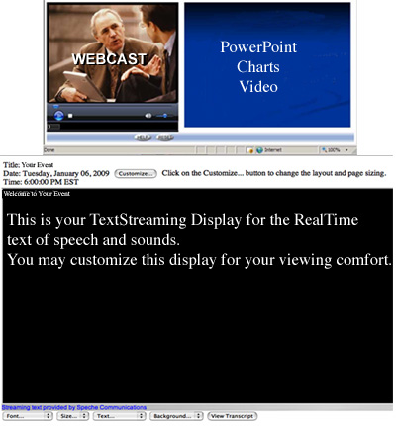

LAUNCHING TEXTSTREAMING

Fifteen minutes prior to the Event:
Please have your computer and any displays powered up;
On the computer, Click on the Active blue-highlighted Event Link below
OR
copy ALL of that blue-highlighted Event Link and paste it into your Internet browser’s address bar and hit ENTER on your keyboard. (The Event Link is one continuous line without any breaks.)

Event Link:
http://www.speche.com/EvtCart/ViewCART.aspx?Org=62035696g352327023

The Event Link will bring you to the Communiqué C.A.R.T. Listing page.

Your Event Title – ALL VR Call - will be listed at the bottom of the page.

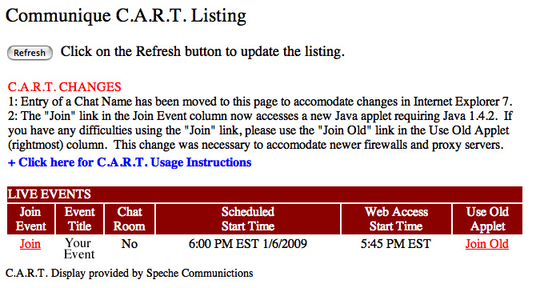

Mouse click on the "JOIN" Link to the left of your Event Title to enter your TextStreaming Display Room.

As the Display Room loads:

Please select "OK" on the Verify Certificate pop-up window AND

IF your Event includes a Chat Room, you will be asked to “Please Enter Your First Name;” this will be the name identifying you in the Chat Room.

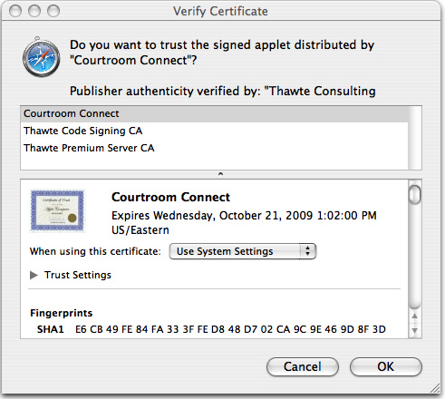

In the TextStreaming Display Room you will see in the display’s upper left corner:
Welcome to All VR CALL.

CUSTOMIZING YOUR TEXTSTREAMING DISPLAY
Before your Event begins, you may Customize the Display for your viewing comfort (change the size, type and color of the font and the background color) via the drop down menus on the bottom of the Display page. The Customize button at the top of the Display page offers different resolutions (screen size) for the entire Display page as well as re-sizing, hiding and repositioning of the Chat Module. As you customize, use the ever-present Event Title as your frame of reference.

THE CAPTION TEST AND REFRESHING THE TEXSTREAMING DISPLAY
15 minutes prior to the Event, a brief Caption test will be performed. You may clear the Caption test by refreshing the TextStreaming Display Room page. Depending upon your browser, you may have to re-customize your Display after refreshing the Display page.

COMMUNIQUÉ TECHNICAL SUPPORT CONTACT
If you are experiencing a problem, prior to or during your Event, you may contact Communiqué via phone (540.775.7742) or IM (on AOL/AIM or Yahoo contact text2u4u). Since Technical Support monitors all projects, prior to and during provision, assistance always is immediately available. To eliminate the risk of spam/virus IM’s, please ensure initial IM messages contain the name of your project.

