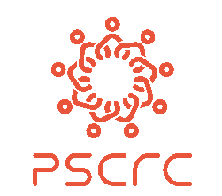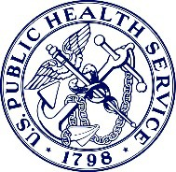

Sickle Cell Awareness Month Webinar Series:
Innovations to Improve Sickle Cell Services Care, Systems, Clinical Workforce, and Address Disparities
Hosted by
Pacific Sickle Cell Regional Collaborative &
HHS Office of the Assistant Secretary for Health, Regions 6, 8, 9 & 10

WEBINAR #1
Innovations in Building Sustainable Statewide Health Systems Improvements for Sickle Cell Disease:
Networking California for Sickle Cell Care (NCSCC)
September 24, 2020 / 11am to 12 noon Pacific

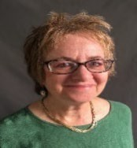

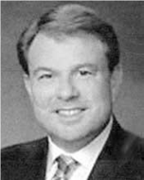

]=
Mary Brown, CEO, | Tony Gonzalez | Judith R. Baker, DrPH, MHSA | Diane Nugent, MD,
Sickle Cell Disease | London & Gonzalez Advocacy | Public Health Director, | Founder/President/Medical
Foundation |  | Center for Inherited Blood  Disorders | Director, Center for Inherited  Blood Disorders

Learning Objectives: Attendees will be able to:
- Describe how the NCSCC serves as a model for a patient advocacy organization to play a leadership role in a coalition’s successful effort to obtain and implement landmark funding to improve SCD services statewide.
- Highlight NCSCC’s successful advocacy strategies, focusing on the role a lobbyist plays, throughout the legislative process to obtain funding, and during service implementation of a multi-year initiative.
- Describe the NCSCC’s public health systems approach to building a network of adult sickle cell clinics, expanding workforce, enhancing surveillance, and increasing education and awareness.
- Outline the NCSCC’s sustainability strategies and Year 1 accomplishments to improve the health of Californians with SCD.
How to Connect to the Webinar:

Registration is NOT required. When it is time to join the webinar, just click the green “Join Meeting” button below and follow the instructions. Note: each webinar has a unique meeting number, password, and “Join Meeting” link.

Questions? Contact Kay A. Strawder, JD, MSW at kay.strawder@hhs.gov
********************
When it's time, join your Webex meeting here.

Meeting number (access code): 199 494 5005
Meeting password: e4NCsEGZS99

Join meeting

Tap to join from a mobile device (attendees only)
+1-415-527-5035,,1994945005## US Toll
Join by phone
+1-415-527-5035 US Toll
Global call-in numbers
Join from a video system or application
Dial 1994945005@hhs.webex.com
Join using Microsoft Lync or Microsoft Skype for Business
Dial 1994945005.hhs@lync.webex.com

