How to Create Layouts
Layouts allow users to personalize how data is displayed. To create a layout in Fiori:
- Open the transaction/app for which you want to create a layout.
- Click the Change Layout icon in the toolbar. Depending on your settings, the Change Layout button will appear as one of the following:
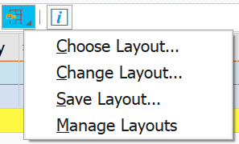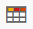
- Add or remove Displayed Columns by clicking the arrows in the center of the screen.
- Move columns up or down to rearrange their display order.
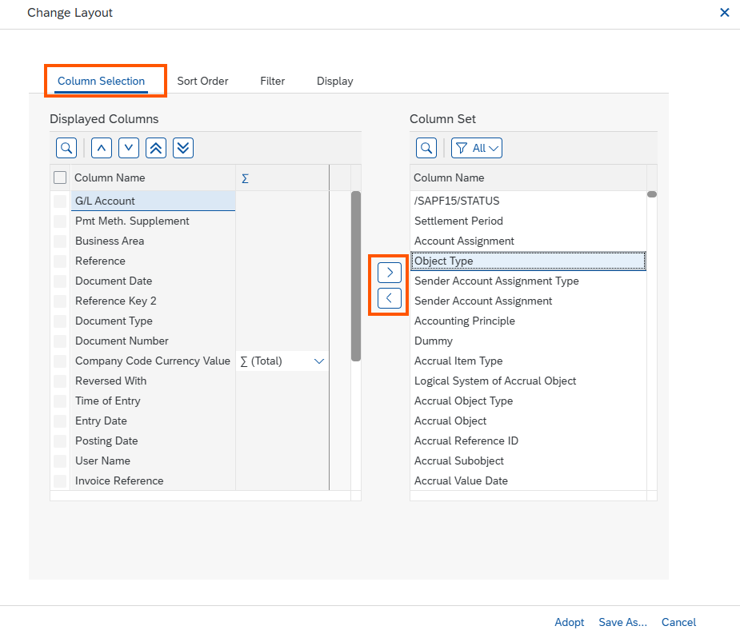
- Click the Sort Order tab to define primary and secondary sorting criteria (e.g., sort by Posting Date).
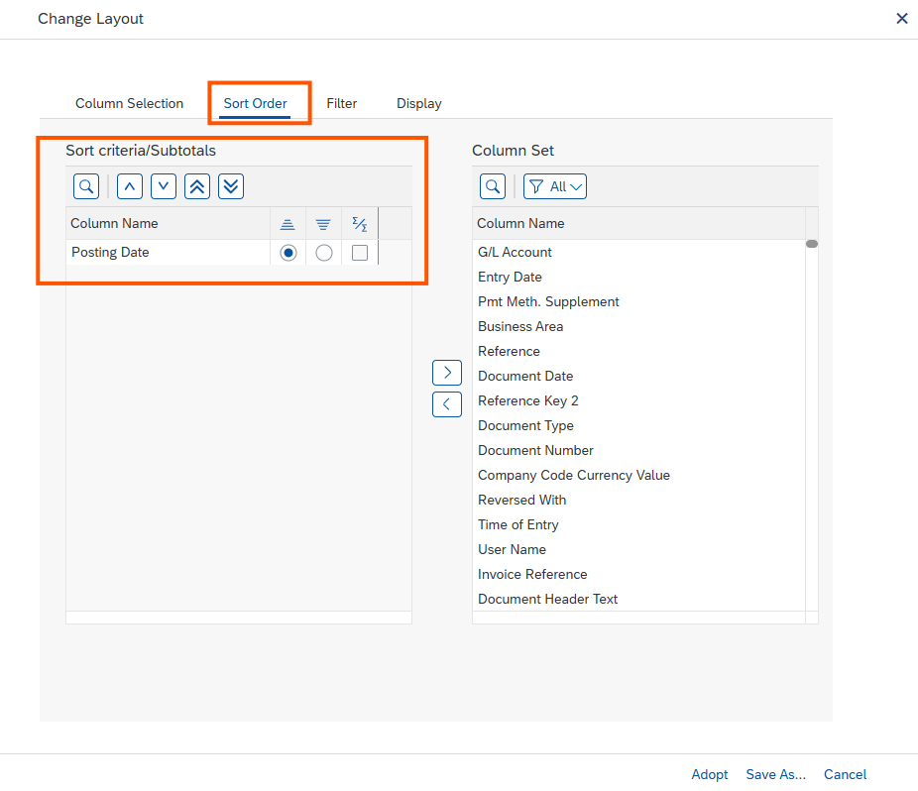
- Make additional changes under the Filer and Display tabs if desired.
- Save the layout by clicking on Save as Layout. Enter the layout name and description.
- Optional: by checking the User Specific box, other users will not be able to view or use the layout.
- Click Adopt.
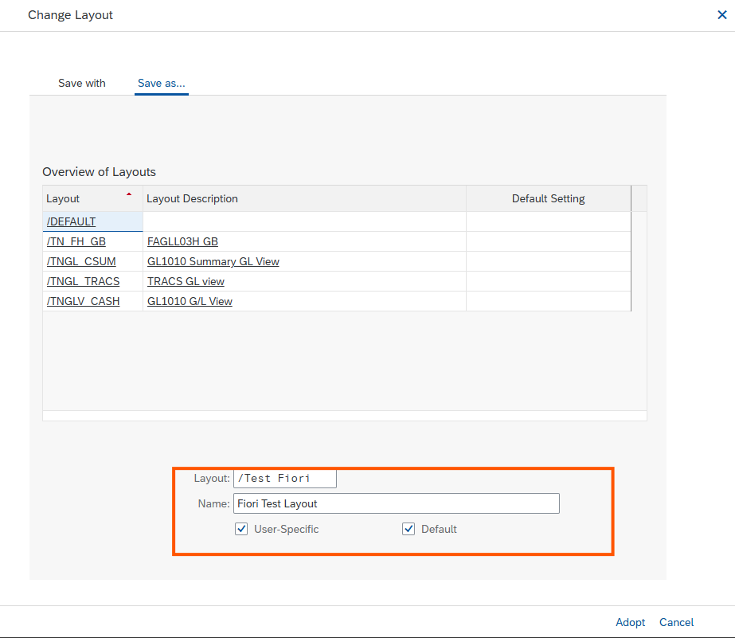

How to Create Report Variants
Report variants allow users to save predefined selection criteria for reports, reducing repetitive data entry. To create a report variant in Fiori:
- Open the transaction/app for which you want to create a report variant.
- In the selection screen, fill in required fields (e.g., Company Code, Ledger, G/L Account, Posting Date). Modify or add additional filters as desired.
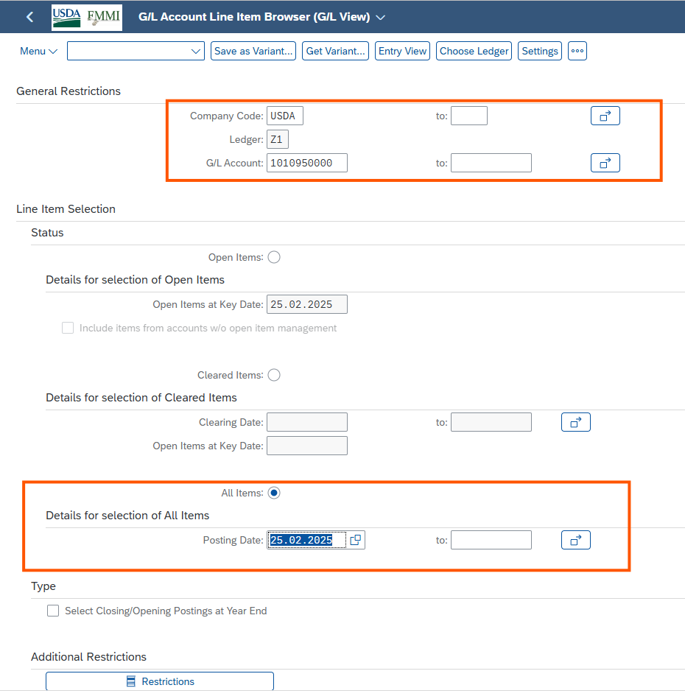
- Click Restrictions in the Additional Restrictions section. A list of additional selection fields will appear in the Dynamic Selections screen.
- Enter the values or ranges for selected fields (e.g., Document Type, Business Area).
- Click Ok or Apply to include them in your selection criteria.
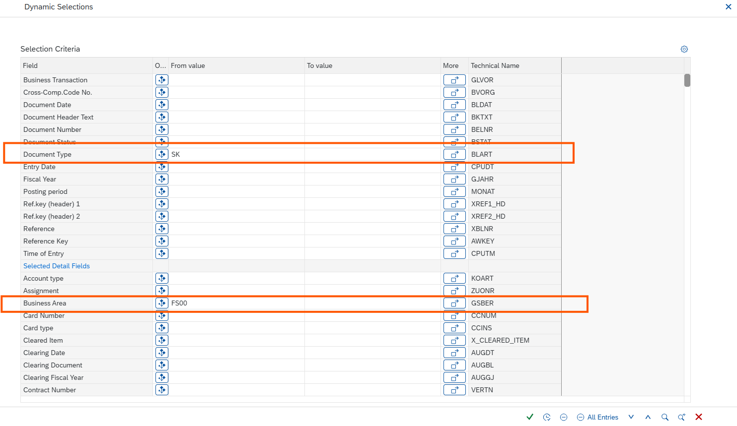
- Click Save as a Variant.
- Enter the Variant Name and Description, then click Save.
