The Library of Congress presents
The Film Foundation’s Story of Movies
The American West and the
Western Film Genre
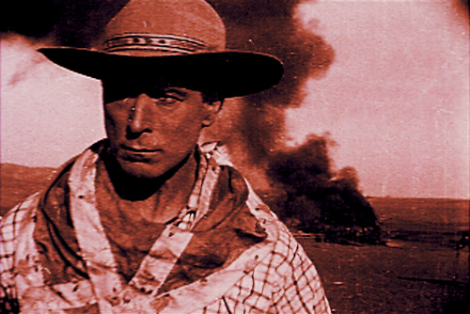
A professional development seminar for educators and librarians,
grades 5 - 12

Wednesday, Thursday, & Friday

August 6, 7 & 8

The Library of Congress
Madison Building
Montpelier Room, Sixth Floor
101 Independence Ave, SE
Washington, DC
Who & What
This free, three-day seminar introduces educators to an interdisciplinary curriculum covering a critical period of American history (1860 – 1900) when the United States was expanding and forging an identity, and explores how filmmakers of the 20th century represented this era.
- Morning workshops focus on cinema literacy/film language and film as historical/cultural document. Handout materials include screening activities and primary source documents to challenge students’ critical-thinking skills.
- Afternoon matinee screenings feature classic Western films, voted culturally and aesthetically significant by the Library of Congress National Film Registry. Pre- and post-screening discussions included.
How & When to Register
- Morning workshops require pre-registration. Classroom capacity is limited to 50.
- Registration deadline for the morning workshops is Monday, July 28, 2014.
Contact
Register by e-mailing Julia Wayne at jwayne@film-foundation.org or call (323) 436-5095.
Please include the following information: name, school, city and state, your contact information, and the subject(s) and grade level(s) you teach.

Note: Overnight accommodations are available in the DC area and are the responsibility of the participant.

Why Teach the Western Film?
“Westerns have always been roadmaps that tell viewers more about the contemporary U.S. than about the country as it existed in the last half of the 19th Century.”
—R. Philip Loy, Westerns in a Changing America
- A rich tapestry of literature, art and social history exists to enhance the study of the Western genre, making it an ideal interdisciplinary subject for classroom study.
- Because the Western is an evolving and changing expression of different stages of American cultural history, investigating the mythology of the Western allows students to interpret how Americans – as well as those in other countries – have viewed American political, social and economic values.
- The decline of the Western genre in the last decades of the 20th Century and early decades of the 21st Century presents an intriguing subject for argument. Why did it decline? What mythology, if any, has replaced the Western to explain our present-day American demographics and value systems?
- Movies are a door to knowledge—of society, of history, of art. The Story of Movies curriculum opens these doors by teaching students to think critically about film, and providing them with a deeper understanding of this uniquely influential art form.
Seminar Schedule
Sessions | Day 1  Wednesday, August 6 | Day 2  Thursday, August 7 | Day 3  Friday, August 8
Registration  9:30 – 10:00 | The Myth of the  American West | The Law and the Land:  Standards of Justice | Industrialism, Nation Building, & the End of the American West
Block 1: Film Language & Elements of Style  10:00 – 11:30 | - Introduction to the Story of Movies Curriculum  - What is a Western Film? Conventions of the Genre | - How to Read a Film: Four Elements of Film Language  - Mise-en-Scène Analysis | - What is a Soundtrack?  - How Music Communicates
Block 2: Historical & Cultural Contexts  12:00 – 1:30 | - Decoding a Film’s Ideology  - Identifying Cinematic Depictions | - Post World War II Westerns: The Town Tamer Western and the Outlaw Western | - The Changing Image of Native Americans in Post WWII Westerns
Lunch Break 1:30 – 2:30
Block 3: Matinee Screening  2:30 – 5:00 | The New Frontier:  The Great Train Robbery  (1903, d. Edwin S. Porter)  The Big Trail  (1930, d. Raoul Walsh) | Violence and Vengeance:  Over Silent Paths  (1910, d. D. W. Griffith)  My Darling Clementine  (1946, d. John Ford) | Racism and Prejudice:  Broken Arrow  (1950, d. Delmer Daves)
The American West and the Western Film Genre supports Common Core State Standards.
Professional development credits may be available through your school district.


About The Film Foundation The mission of the Film Foundation, a non-profit 501(c)(3) organization founded by Martin Scorsese and other prominent filmmakers, is to preserve America’s cultural and artistic film heritage and to ensure that classic films remain accessible to future generations. The foundation’s educational programs are designed to raise awareness of the urgent need to protect and preserve motion picture history, and to create an understanding of the social and cultural significance of film. In keeping with this mission, the foundation developed The Story of Movies, working closely with American filmmakers, scholars, and classroom educators. This groundbreaking educational initiative exposes middle and high school students to classic cinema, teaches them how to understand the visual language of film, and encourages them to appreciate the social, historical, and cultural significance of film.

