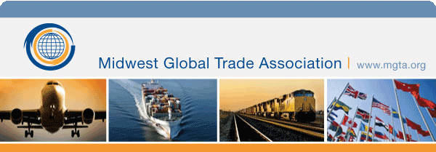

Be one of the FIRST in the United States to attend this seminar
Incoterms 2020
When: | Monday, September 23, 2019  7:30 am – 4:30 pm
Where: | The Wilds Golf Club - Banquet Room  3151 Wilds Ridge Ct  Prior Lake, Minnesota 55372  United States
Contact: | John Novak  janovak@bremer.com  612-782-2819
Online registration is available until: 9/23/2019
Registration Now Open!
https://www.mgta.org/event/2019-sep-incoterms#

All registrations must be accompanied by full payment/purchase order to reserve your place at the event.

Agenda
7:30 a.m. | Registration & Breakfast
8:30 a.m. | Program
10:15 a.m. | Break
10:30 a.m. | Program
12:00 a.m. | Lunch
1:00 p.m. | Program
2:15 p.m. | Break
2:30 p.m. | program
4:30 p.m. | Adjourn

Who Should Attend
- Exporters
- Importers
- Sales Managers
- Purchasing Managers
- Forwarders
- Customs Brokers
- Carriers
- Credit Professionals
- Insurers
- Trade Consultants
- International Bankers
- Attorneys
- Domestic Sales
- Anyone involved with International Trade, Supply Chain, Global Management

Overview
- Why Incoterms rules
- The revision process
- What Incoterms are & aren’t, do & don’t do
- Summary of 2020 major changes
- Role in contracts
- Seller to buyer
- Transportation terms
- Insurance
- Rule by rule analysis
- American perspective
- What happened with the UCC shipment / delivery terms

Speaker

Frank Reynolds
Frank Reynolds is uniquely qualified to explain Incoterms® 2020 rules to Americans. He brought over 50 years of hands-on practical expertise to the 2020 Incoterms® revision where he represented the United States as he did for the 2000 and 2010 revisions.
Frank has been instructing trade-related topics for over 35 years, served thirteen terms on the U.S. Department of Commerce District Export Council, and holds a U.S. customs broker license. His company, International Projects Inc., is a 40+ year old full service trading and consulting firm. It received the U.S. Department of Commerce “E” and “E-Star” Awards for Excellence in Export Service.
Frank has written or co-authored eighteen books on international trade related topics. His Incoterms® for Americans®, now in its fourth revision, is a major reference for U.S. traders and is included as a seminar material. He has also written hundreds of trade-related columns for the Journal of Commerce, The Exporter, Managing Exports and the ICC’s Documentary Credit Insight.

Registration Fee

$350

PCI Compliance: MGTA has taken the appropriate steps to maintain PCI compliance. In order to protect your privacy, please do not email your credit card information to our office.
Cancellation Policy: With written cancellation notice, received at least 1 week prior to the event, you will receive a full refund, minus a $10 administrative fee. No-shows will not receive refunds.
Audio/Video Policy: Registration and attendance at, or participation at association events constitutes an agreement by the registrant to association’s use and distribution of the registrant or attendee’s image or voice in photographs, videotapes, electronic reproductions and audiotapes of such events and activities.

