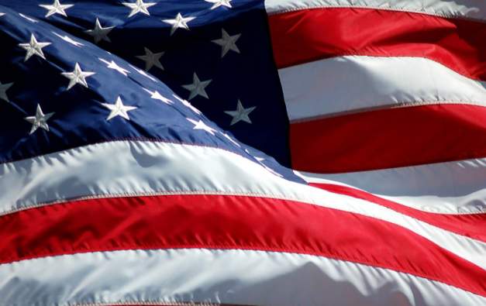

Webinar: Doing Business in the Baltics – Estonia, Latvia, Lithuania

Export2Europe Webinar: Doing Business in the Baltics – Estonia, Latvia, Lithuania

May 30, 2019 at 11:00am ET (8:00am PT) cost: $50

The U.S. Department of Commerce invites American exporters to a webinar discussing market opportunities and challenges in the Baltics. With a regional GDP of over $121 billion, a GDP per capita on average of $20,000, strong infrastructure and ease of doing business, this region of just over 6 million people offers opportunities for American exporters. All three countries are members of the European Union, NATO and the eurozone, and are considered high income economies. Join us to hear about these unique and fast growing European markets!

Why the Estonia?
Estonia hosts NATO's cyber-defense center and is a homeland for of Skype. As a result of its two-decade commitment to IT, Estonia is the world’s most advanced digital society and recognized leader in digital skills, infrastructure and legislation. Estonia boasts a full digital ecosystem, world class cyber-security, and soon-to-be 5G infrastructure. Skype, Transferwise, GrabCAD, Skeleton, Lingvist are just a few of many successful technology startups born in Estonia.

Why Latvia?

Latvia is ranked 25th out of 189 countries in terms of ease of doing business. The Latvian government has adopted modern laws establishing copyrights, patents and trademarks and the means for enforcing their protection. Telecommunication services are modern and among the highest in quality in the EU. Many U.S. companies doing business in Latvia rate the business environment among the best in Central and Eastern Europe. The country provides an attractive market for American IT equipment and services, capital machinery and equipment, medical and consumer products, and energy products.

Why Lithuania?

Among the fastest growing EU economies, Lithuania is a relatively small, but potentially attractive market for U.S. goods and services. Its excellent infrastructure, competitive costs, and availability of high-skilled, English-speaking workforce make Lithuania a great place for U.S. companies to do business. Dominant sectors include biotechnology, financial technology, electronics manufacturing, ICT, laser technology, energy, metal working, and transportation and logistics. Major upcoming infrastructure projects include expansion of the Klaipeda Sea Port, estimated at 800 million euros.

Join us to discuss opportunities in the Baltics!
As well as highlighting trends and opportunities in the Baltics, this webinar will identify key projects taking place. Learn from European experts who will offer practical advice to U.S. SMEs looking to do business in the region.

Featured Speakers:
- Reene Moschella, Econ/Commercial Specialist, Estonia
- Michael Ritchie, Political / Economic Officer, Latvia
- Amy Reichert, Economic Officer, Lithuania

Register today

Click here to register

Event date

May 30, 2019

Time
11:00 am ET
8:00am PT

Location
Your Computer and Phone

Cost
$50.00

More information

Michael Muth
Michael.muth@trade.gov

