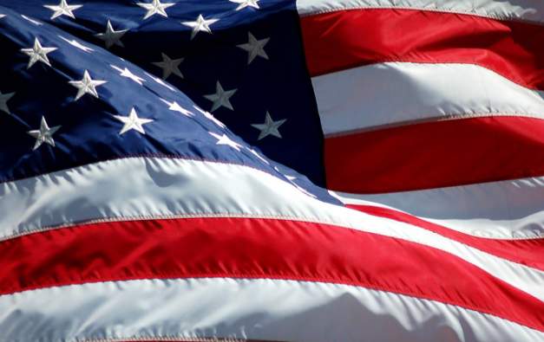
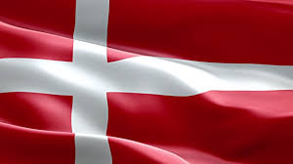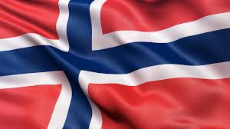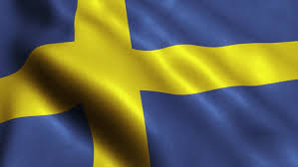

Webinar: Doing Business in the Nordics

Why Denmark?
Denmark is a rich, modern society with state-of-the-art infrastructure and distribution systems. It has 5.7 million inhabitants and an advanced high-tech society. Denmark ranks as the most advanced digital country in the EU and is characterized by an extensive welfare system with a substantial trade and investment relationship with the U.S. The country has an open market-based economy with substantial investments in areas such as infrastructure, healthcare, digitalization, energy, defense and always looking for innovative solutions.

Why Finland?
This $250 billion economy and its immensely innovative culture ranks 3rd in the EU Digital Economy and Societal Index, 7th in the Global Innovation Index, and in the world’s top 3 strongest health technology economies. Pioneering companies the world over meet here to spearhead the next generation in ICT (including 5G), eHealth, energy, cleantech, Smart Cities, and other knowledge-based growth industries. If you seek a lucrative export market, an ideal testbed, and partners eager to build your solutions into the DNA of the next global breakthrough.

Why Norway?
Norway is a modern, energy-rich country with 5.3 million people. It is considered one of the world's wealthiest countries with a GDP per capita exceeding $72,000. Norway represents a highly digital and sophisticated market, including large-scale critical infrastructure tied to its leading industries, which are based on natural resources, energy, digitalization, defense, aerospace, and ocean technologies. Norway is the largest export market for U.S. goods in the Nordics. The U.S. and Norway maintain a $17 billion two-way trade relationship.

Why Sweden?
Over 1,300 U.S. companies are present in Sweden, Sweden is the top location in the Nordics. The U.S. is Sweden’s largest trading partner outside of the EU. In 2017, U.S. merchandise exports to Sweden were valued at $3.73 billion and imports were $10.74 billion. The U.S. exported $5.9 billion in services to Sweden in 2016 and imported $3.1 billion. Our Embassy’s focus sectors include advanced manufacturing, smart cities, cybersecurity, healthcare, and travel/tourism.

Join us to discuss opportunities in the Nordics!
Learn about trends and opportunities in these markets from European experts who offer practical advice to U.S. SMEs looking to do business in the region.

Featured Speakers:
- Bjarke Fredriksen, Head of Section, CS Copenhagen, Denmark
- Aaron Held, Senior Commercial Officer, CS Helsinki, Finland
- Vidar Keyn, Head of Section, CS Oslo, Norway
- Terri Tyminski, Deputy Senior Commercial Officer, CS Stockholm, Sweden

Register today
Click here to register

Event date
Tuesday
April 16, 2019

Time
12:00 pm/noon EST

Location
Your Computer and Phone

Cost
$50.00

More information

Michael Muth
Michael.Muth@trade.gov
(202) 482-2682

