Youth Create! Content Promotion Toolkit for Youth
Authentic youth engagement benefits both youth and youth-serving programs by providing adolescents with needed opportunities for growth and self-expression and informing programs about how to better meet the needs of youth. OPA sincerely thanks you for being part of Youth Create! and helping us share the perspectives of your peers across the country on health, COVID-19, and teen pregnancy prevention. We have included sample social media posts and article that can be used in your school newsletter or social media.
You also can develop your own social media posts and/or articles to share this work, and we encourage you to do so.
Posting Guidelines: This project is sponsored by the federal government, and we ask that you avoid profanity, use respectful language, avoid promoting commercial products or services, and do not engage in bullying or harassment. The sample posts do not contain any personal social media handles. If you are sharing your own work or that of your friends, please feel free to credit and tag each other in the work using your own social media handles.

Key Links
These are the links you can use to share the work by youth who participated in Youth Create!. Please pick the one that best matches your post (for example, use the compilation video link or website link if talking about Youth Create! generally, or the link to a submission if you’re talking about that specific work).
- Compilation video
- Collection of all youth-created submissions on the OPA website
- The Truth Untold (OIC, Florida)
- YLC You and Me (OIC, Florida)
- Our Past, My Present, the World’s Future (Project STIQ, New York)
- What Does a Healthy Future Mean to You and Others Your Age? (PROSa, Puerto Rico)
- Youth Optimal Health (Campesinos Sin Fronteras, Arizona)
- YES for Health. YES for Hope. (TRUST, California)
- Bloom and Doom (Project STIQ, New York)
- Change (Project STIQ, New York)
- You Are Not Alone (Campesinos Sin Fronteras, Arizona)
- Love Yourself (Campesinos Sin Fronteras, Arizona)

Sample Social Media Posts

General Posts
These posts can be used whether you personally submitted to Youth Create! or not. They are formatted for Twitter, but you can adapt them to any social media platform. If you adapt them to another platform, please change “@HHSPopAffairs” to “The HHS Office of Population Affairs.”
.@HHSPopAffairs invited youth from Teen Pregnancy Prevention programs like [insert your program’s name/handle] to participate in Youth Create! and share their thoughts on health, COVID-19, and teen pregnancy prevention. Here are some of the highlights. https://www.youtube.com/watch?v=iCFZpgG2tGc
Young people are speaking out about what they want and need to be healthy in @HHSPopAffairs’ Youth Create! call for content. Hear what we have to say! https://www.youtube.com/watch?v=iCFZpgG2tGc
It’s great to see the videos, poems, and art submitted by other youth as part of @HHSPopAffairs’ Youth Create! I liked getting to hear about [insert something that stuck out to you]. https://www.youtube.com/watch?v=iCFZpgG2tGc

Posts for Youth Sharing Their Submissions
These posts are designed to help youth who submitted to Youth Create! share their work. The posts are formatted for Twitter but can be adapted for any social media platform. If you adapt the posts to another platform, please change “@HHSPopAffairs” to “The HHS Office of Population Affairs.”
My [video/poem/art], [title if desired] is featured as part of the @HHSPopAffairs Youth Create! call for content. I wanted to make sure people understood [insert a key takeaway from your work]. https://opa.hhs.gov/youth-create
Check out this [video/poem/art] that I made with my friends in [insert your program’s name/handle] for @HHSPopAffairs Youth Create!. Health is important to us and we want you to hear our voices. [insert link to submission]
I’m proud that I got to work on [insert title] for @HHSPopAffairs Youth Create! My favorite part of the project was [insert something you enjoyed from the process]. Check out the final product! [insert link to submission]

Sample Image for Social Media Posts
The following image can be used to enhance your social media posts. If you share one of the YouTube links, the video will populate into the social media post. You can also share the original file or an image of your submission.
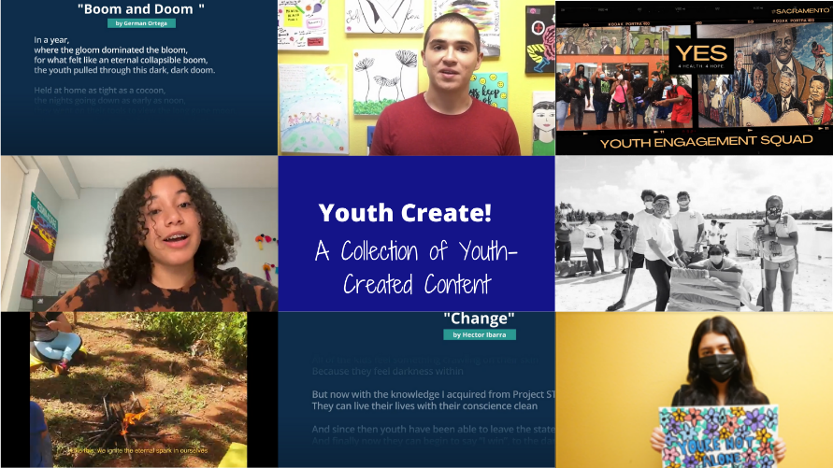

Sample Newsletter Blurb/Article
The following template allows you to create a newsletter or newspaper article featuring the work submitted to Youth Create! by your program. You can submit it to your school or local newspaper or school newsletter. It also can easily be adapted for a blog. If needed, you can ask for help from your program staff.
Young people have been through a lot with the pandemic, in addition to the other challenges that affect our communities and our health. Recently, youth in [insert your program name], a local teen pregnancy prevention (TPP) program funded by the U.S. Department of Health and Human Services Office of Population Affairs (OPA), were invited to submit to Youth Create! – OPA’s call for youth-created content. Youth Create! asked youth to submit videos, poems, stories, art, photos, and voice recordings that share their perspectives on coping with the COVID-19 pandemic, the impact of being in a TPP program, and their hopes for a healthy future.
[Insert program name] submitted a total of [insert number and type of submissions from your program], created by [insert names of individuals or groups who worked on the submission]. Their work highlights [insert key takeaway from submission]. Participants worked on their entries during [fill in details with how the work came together]. View the full [video/poem/artwork (insert link to submission)].

