Youth Create! Content Promotion Toolkit for Grantees
Youth Create! is a collection of youth-created content that was launched by the Office of Population Affairs (OPA) in 2021. Authentic youth engagement benefits both youth and youth-serving programs by providing adolescents with needed opportunities for growth and self-expression and informing programs about how to better meet the needs of youth. OPA truly values the submissions received from youth and programs across the country, and we want to amplify their work as much as possible. Please use the sample social media posts and newsletter blurbs below to share Youth Create! content. You can use the materials as provided or modify them to match your organization’s voice. We’ve also created a separate Toolkit for Youth. Please help the youth in your programs use the sample social media posts and newsletter blurbs from the Toolkit for Youth to get their voices heard!

Sample Social Media Posts
These posts are formatted for Twitter, but you can adapt them to any social media platform. If you adapt them to another platform, please change “@HHSPopAffairs” to “The HHS Office of Population Affairs.”
OPA invited youth from its Teen Pregnancy Prevention grantee programs, like [insert program name], to share videos, stories, art, photos, and voice recordings in Youth Create! View the compilation video. https://www.youtube.com/watch?v=iCFZpgG2tGc @HHSPopAffairs #OPAYouthCreate

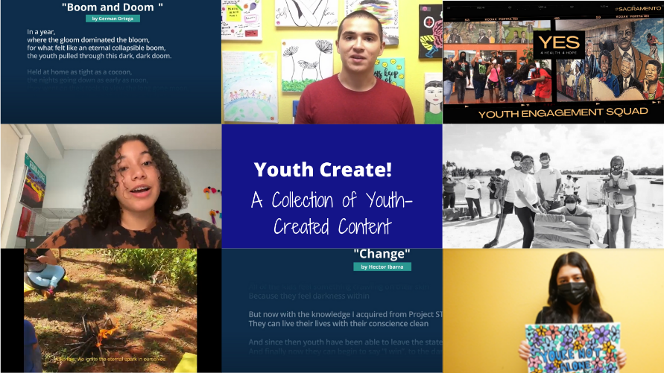

The #OPAYouthCreate collection of youth work answers these prompts: What has helped you and other youth get through the pandemic? How has being part of a TPP program impacted your life? What does a healthy future mean to you and others your age? https://opa.hhs.gov/youth-create

“The Truth Untold” video by Claudine, Monica, and the OIC Teen Pregnancy Prevention Youth Leadership Council in Florida shared how their TPP program has helped them get through the pandemic and affected their lives. #OPAYouthCreate https://www.youtube.com/watch?v=4__RppvhNvI

Dorissa, Leriana, and youth from the OIC Teen Pregnancy Prevention Youth Leadership Council in Florida also submitted an animated video “YLC You and Me” detailing their TPP program’s activities and how it has supported their growth. #OPAYouthCreate https://www.youtube.com/watch?v=OyVy84UajnQ

Tanya from Project STIQ in New York performed her poem, “Our Past, My Present, the World’s Future,” which shares what she has learned in her TPP program and how it matters in the context of current events. #OPAYouthCreate https://www.youtube.com/watch?v=q7BVNUjGVng

Youth from PROSa in Puerto Rico developed a collaborative poem and video highlighting their hopes for a healthy future and the supports they need to achieve their vision. #OPAYouthCreate https://www.youtube.com/watch?v=62QJlysQG-o

German from Project STIQ in New York submitted a poem “Bloom and Doom” that discusses the challenges of being a teen in the pandemic and the resilience youth have displayed. #OPAYouthCreate https://opa.hhs.gov/youth-create

Angel, Rubi, and Josephat from Campesinos Sin Fronteras in Arizona did a Q&A for their video, “Youth Optimal Health,” and tackled all three #OPAYouthCreate questions. https://www.youtube.com/watch?v=N5VsVvzIgLc

The “YES for Health. YES for Hope” video/photo essay by youth from the TRUST program in California documents their dreams for a healthy future and the communal challenges around equity they are striving to address. #OPAYouthCreate https://www.youtube.com/watch?v=r4omWhJPnMo

“Change,” a poem by Hector from Project STIQ in New York, captures the feeling of seeing his peers affected by STIs and the empowerment of having the information to help them make healthy choices in the future. #OPAYouthCreate https://opa.hhs.gov/youth-create

Rubi from Campesinos Sin Fronteras in Arizona gave us a painting with a clear message for all youth struggling in the midst of the pandemic. https://opa.hhs.gov/youth-create
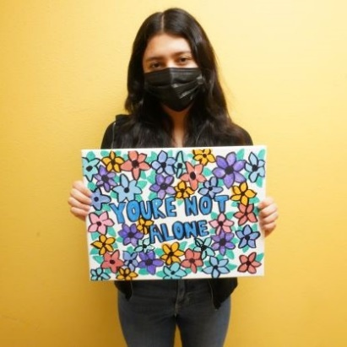

This painting from Angel from Campesinos Sin Fronteras in Arizona is a great reminder about showing up for ourselves. #OPAYouthCreate https://opa.hhs.gov/youth-create
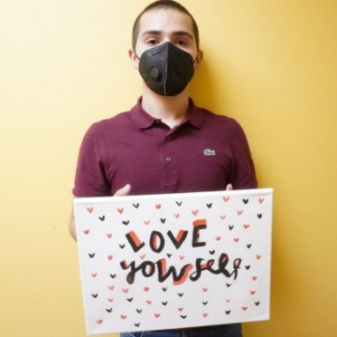

Sample Newsletter Blurb
As part of its youth engagement efforts, the U.S. Department of Health and Human Services Office of Population Affairs (OPA) launched a call for youth-created content: Youth Create! OPA invited young people ages 13-21 from its Teen Pregnancy Prevention (TPP) grantee programs to share videos, poems, stories, art, photos, and voice recordings. Submissions addressed at least one of the following prompts: What has helped you and other youth get through the pandemic? How has being part of a TPP program impacted your life? What does a healthy future mean to you and others your age? Explore the collection of youth-created content or view the compilation video [Organization name, “we”, etc.] would like to highlight the following submissions [choose submissions to highlight from those below]:
- The Truth Untold by Claudia, Monica, & the OIC Teen Pregnancy Prevention Youth Leadership Council, Florida
- YLC You and Me by Dorissa, Leriana, & the OIC Teen Pregnancy Prevention Youth Leadership Council, Florida
- Our Past, My Present, the World’s Future by Tanya, Project STIQ, New York
- What Does a Healthy Future Mean to You and Others Your Age? by Youth from PROSa, Puerto Rico
- Youth Optimal Health by Angel and Rubi, Campesinos Sin Fronteras, Arizona
- YES for Health. YES for Hope by TRUST (Pro Youth and Families): Youth Engagement Squad, California
- Bloom and Doom by German, Project STIQ, New York
- Change by Hector, Project STIQ, New York
- You Are Not Alone by Rubi, Campesinos Sin Fronteras, Arizona
- Love Yourself by Angel, Campesinos Sin Fronteras, Arizona

