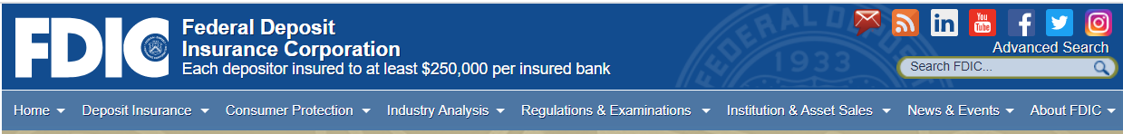

Free Webinar
Preserving Public Confidence in the U.S. Banking System in the COVID-19 Era; a Federal Deposit Insurance Corporation Financial Capability Event

When: Thursday, April 30, 2020, 10:00 – 11:30 AM

Who should attend:
- Community Organizations
- Financial Institutions, especially Community Reinvestment and Development Officers
- Public Sector Agencies
- Academia
- Other Intermediaries

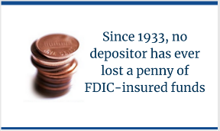
This is the FDIC’s core commitment to the public. The pathway to individual and family financial capability runs through mutually beneficial relationships with mainstream banking institutions, aided by FDIC’s efforts to educate and protect consumers, revitalize communities, and promote compliance with laws and regulations. All of this is especially important as our nation responds to COVID-19’s impacts.

Staff from FDIC’s Divisions of Depositor and Consumer Protection and Risk Management Supervision will share Information and Resources about key ways they support the commitment. Over the course of 90 minutes, the webinar will cover several key FDIC roles:

- Deposit Insurance
- Financial Institution Supervision
- Consumer Response Center
- Community Affairs
- and other public-facing resources such as the FDIC Consumer News

There is no cost to join the webinar, but advance registration is required.
REGISTER HERE no later than 12:00 Noon on Wednesday April 29.

Thanks for your attention. We look forward to your participation!

For more information, please contact one of our Community Affairs Specialists:

Darnell Sutton – DSutton@FDIC.gov
Paul Horwitz – PHorwitz@FDIC.gov
Robert Francis – RoFrancis@FDIC.gov

