Social media toolkit

ANnouncing FDA’s Snack Shack:
nutrition Destination for Kids
at Whyville.com
LAUNCH DATE: March 15, 2016

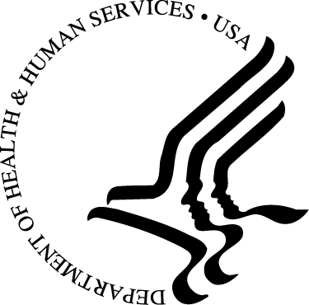
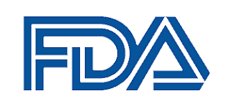

BACKground
March is National Nutrition Month®, and while the U.S. Food and Drug Administration (FDA) encourages all Americans to read the Nutrition Facts Label on packaged foods and beverages to make healthful dietary choices, it’s especially important for youth, who are learning to build lifelong habits as they compare and choose foods. To help young people understand and practice using the Nutrition Facts Label, FDA announces its newest educational program: The FDA Snack Shack, located in the virtual world of Whyville.

Through this new online gaming experience, Whyville’s 7 million young citizens (ages 8 to 14) will obtain hands-on experience in understanding and using the Nutrition Facts Label to compare and select snacks and other foods. By practicing label reading in the online community, kids will develop new skills for making smart snack choices in the real world.
The new program site destination http://snackshack.whyville.com is launching on Tuesday,
March 15, 2016, at 10:07 a.m., ET.

We hope you will use the information provided in this toolkit to help us promote the launch of the Snack Shack. Please go to FDA’s Facebook, Twitter, and Pinterest sites to access usable graphics and/or retweet, repost, or re-pin. You can also find many other resources on the Nutrition Facts Label on FDA’s website. Thank you for your support!

Key hashtagS

- #FDASnackShack
- #Whyville
- #Nutrition
- #Education
- #BackToSchool (For August follow up)

accounts to follow/Retweet
- @US_FDA
U.S. Food and Drug Administration
- @FDAFood
FDA’s Center for Food Safety and Applied Nutrition

- @FDAWomen
FDA’s Office of Women’s Health
- @FDAOMH
FDA’s Office of Minority Health

- @WhyvilleNews
Whyville
- @girlshealth
HHS Office on Women’s Health site for girls, ages 10–16

- @AmerAcadPeds
American Academy of Pediatrics

TIMELINE
- Tuesday, March 15: Launch announcement across all channels/URL announced
- Friday, March 18: Reminder announcement
FOLLOW UP:
- Monday, August 1: Back-to-school message

Facebook: Facebook.com/fda
- Launch Post (March 15)
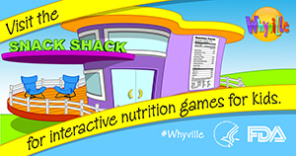
Attention Parents: FDA’s Snack Shack in Whyville has two new interactive online games that help kids learn how to use the Nutrition Facts Label and make healthy snack choices. Check out these fun games in the Snack Shack—launching today at http://snackshack.whyville.com #FDASnackShack #Whyville #Nutrition

- Reminder Post (March 18)

Looking for a fun way to get kids interested in making healthy snack choices? Check out the FDA’s new Snack Shack in Whyville with its interactive online games that help kids learn how to use the Nutrition Facts Label! http://snackshack.whyville.com #FDASnackShack #Whyville #Nutrition
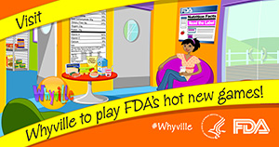
- Back to School (August 1)

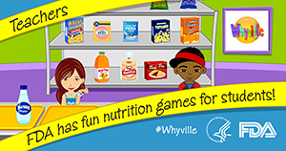
Parents and Teachers: The sooner the better! That’s right, the sooner children learn how to use the Nutrition Facts Label the earlier they’ll start making healthy snack choices. FDA’s new Snack Shack games, which are fun and educational, will help kids do just that! Check out our new interactive games in Whyville at http://snackshack.whyville.com #FDASnackShack #Whyville #BackToSchool #Education

Twitter: Twitter.com/fdafood
- Launch Tweet (March 15)
Kids ages 8 to 14 will love the new #FDASnackShack game in the virtual world of #Whyville ⇛ http://snackshack.whyville.com #Nutrition

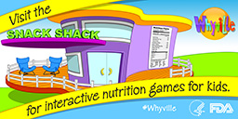

- Reminder Tweet (March 18)
Become a #Whyville citizen today & play FDA's hot new online game for kids at http://snackshack.whyville.com #Nutrition

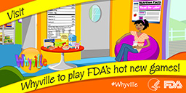

- Back-to-School Tweet (August 1)
Attention Teachers: Engage your students with online games for classroom use in #Whyville http://snackshack.whyville.com #BackToSchool

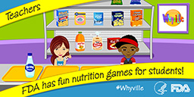

PINTEREST: www.pinterest.com/usfda
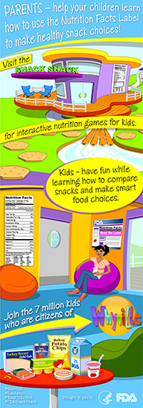
Whyville Snack Shack Pin(s)

- Launch Pin (March 15)
Attention Parents: FDA’s Snack Shack in Whyville has two new interactive online games that help kids learn how to use the Nutrition Facts Label and make healthy snack choices. Check out these fun games in the Snack Shack—launching today at http://snackshack.whyville.com #FDASnackShack #Whyville #Nutrition

- Reminder Pin (March 18)
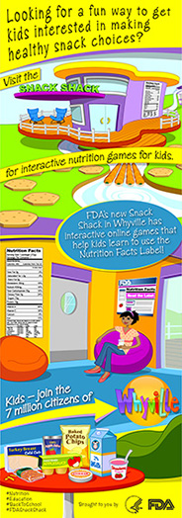
Looking for a fun way to get kids interested in making healthy snack choices? Check out the FDA’s new Snack Shack in Whyville with its interactive online games that help kids learn how to use the Nutrition Facts Label! http://snackshack.whyville.com #FDASnackShack #Whyville #Nutrition

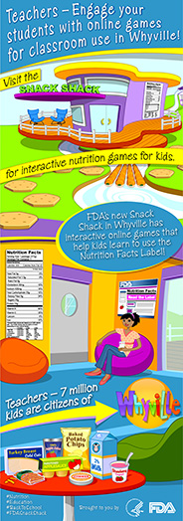
- Back to School Pin (August 1)
Parents and Teachers: The sooner the better! That’s right, the sooner children learn how to use the Nutrition Facts Label the earlier they’ll start making healthy snack choices. FDA’s new Snack Shack games, which are fun and educational, will help kids do just that! Check out our new interactive games in Whyville at http://snackshack.whyville.com #FDASnackShack #Whyville #Education #BackToSchool

®2016 eatright.org. Academy of Nutrition and Dietetics

