Social Media Posts

🚨 A new report from the Johns Hopkins Evidence-based Practice Center underscores that Emergency Medical Service personnel are at ⬆️ risk of #COVID19 compared to other frontline emergency personnel. [provide link to the report]

Tags: @NHTSAgov

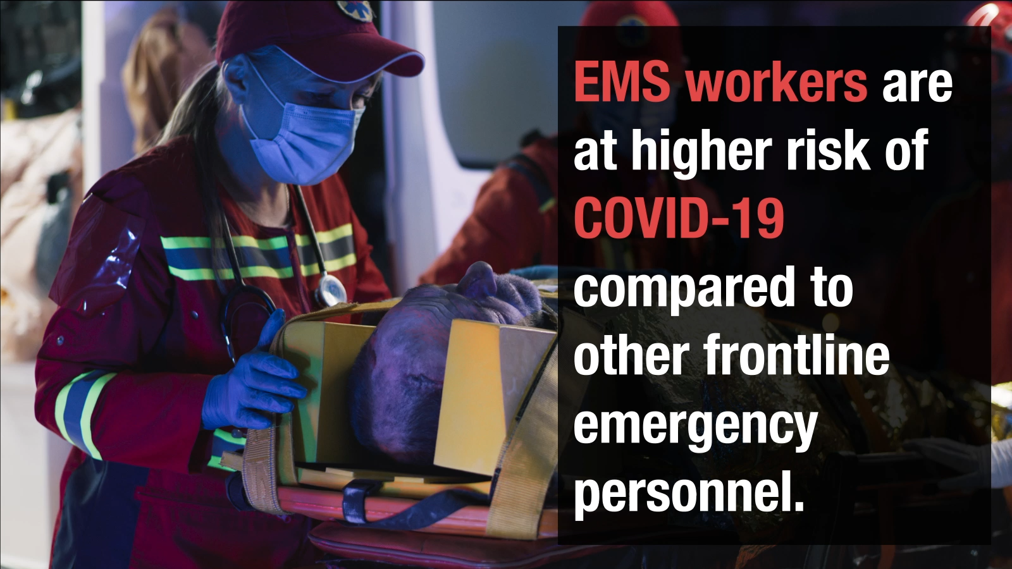

🤔 Did you know that Emergency Medical Service workers, like paramedics, have 4x greater risk for #COVID19 than other emergency personnel? Learn more from the Johns Hopkins Evidence-based Practice Center’s new report! [provide link to report]

Tags: @NHTSAgov

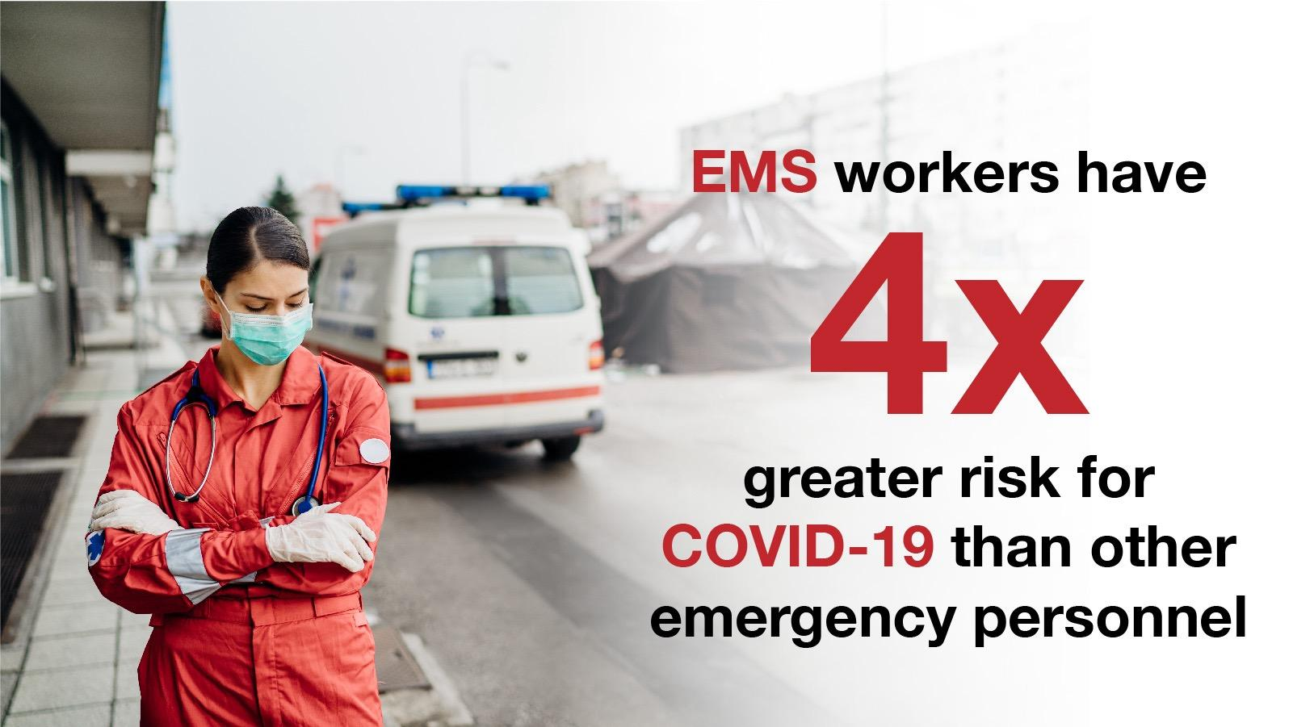
Just in! Johns Hopkins Evidence-based Practice Center @JohnsHopkinsSPH released a report highlighting the importance of regular hand hygiene in decreasing the risk of infections, such as methicillin-resistant Staphylococcus aureus, in Emergency Medical Service workers.
[provide link to report]

Tags: @NHTSAgov

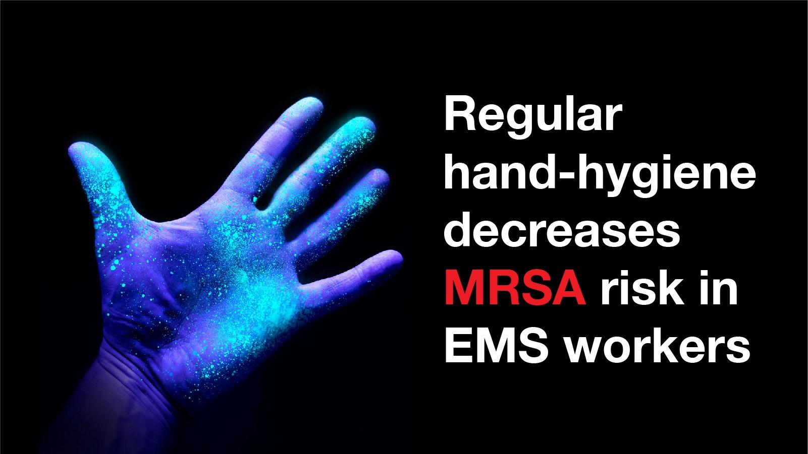

🚨 New report alert! Johns Hopkins Evidence-based Practice Center @JohnsHopkinsSPH
report stresses that use of gloves decreases the risk of needlestick exposures and bloodborne infections in Emergency Medical Service workers. [provide link to report]

Tags: @NHTSAgov

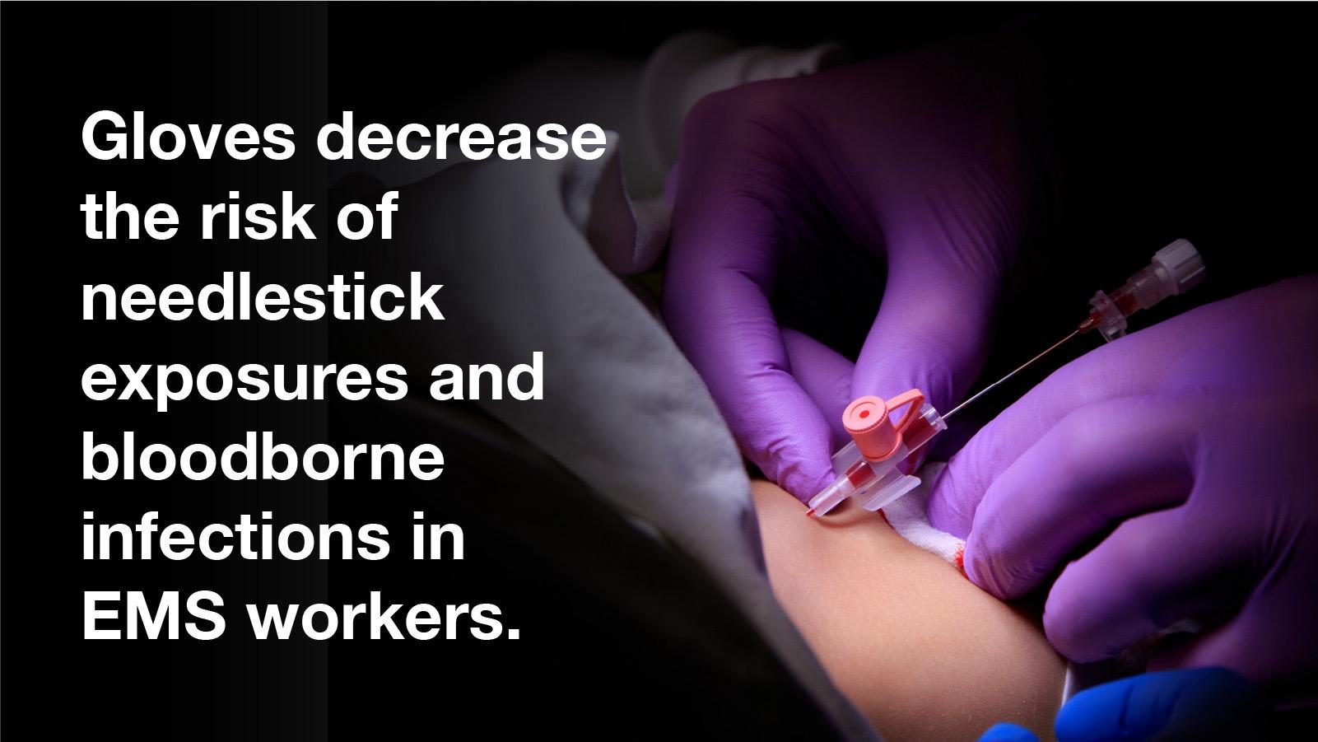

💉 Onsite directed clinics and educational programs boost vaccine uptake by Emergency Medical Service personnel. Read more in the Johns Hopkins Evidence-based Practice Center’s new report! [provide link to report]

Tags: @NHTSAgov, @JohnsHopkinsSPH

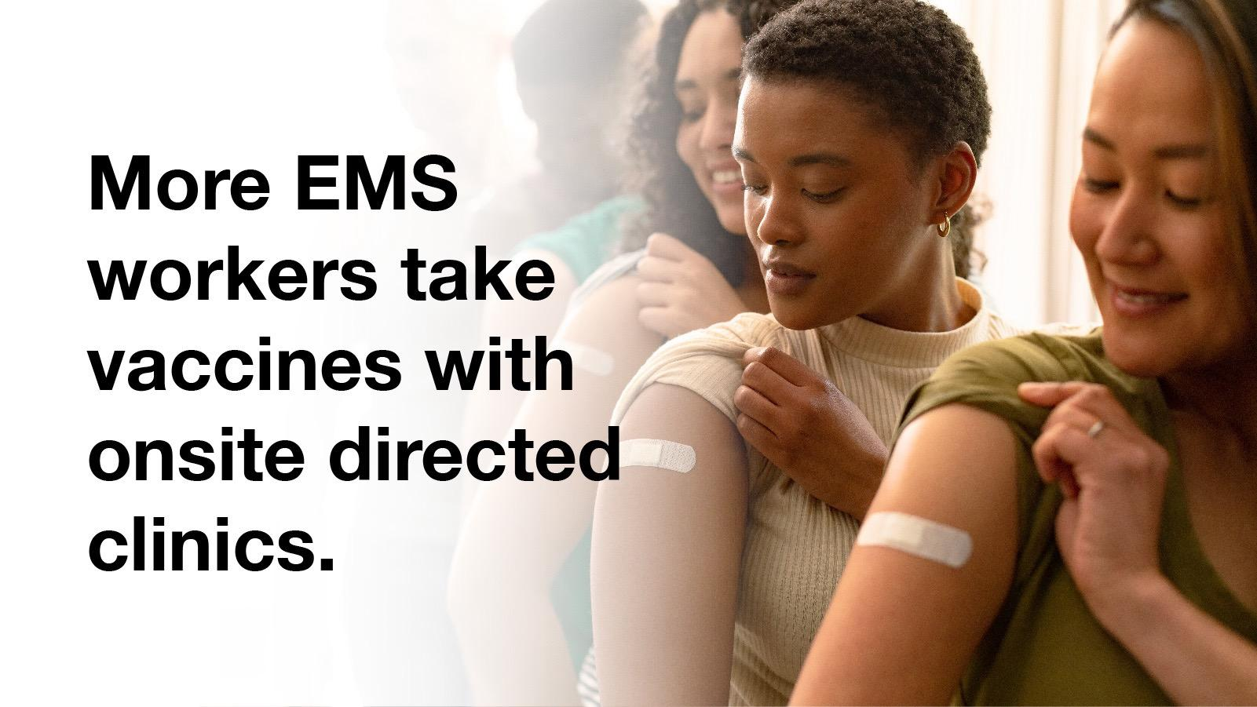

The #COVID19 pandemic has highlighted the need for better understanding of ways to reduce the risk of infections in Emergency Medical Service workers. Read the Johns Hopkins Evidence-based Practice Center’s new report on infections in EMS workers! [provide link to report]

Tags: @NHTSAgov

