NPSTW 2024 SOCIAL MEDIA POSTS

- In Honor of NPSTW
This National Public Safety Telecommunicators Week, we honor and celebrate our dedicated 911 #publicsafetytelecommunicators who play a vital role as our nation’s first first responders. Their commitment, compassion, and lifesaving skills improve our communities every day of the year. #NPSTW #911dispatchers #911professionals


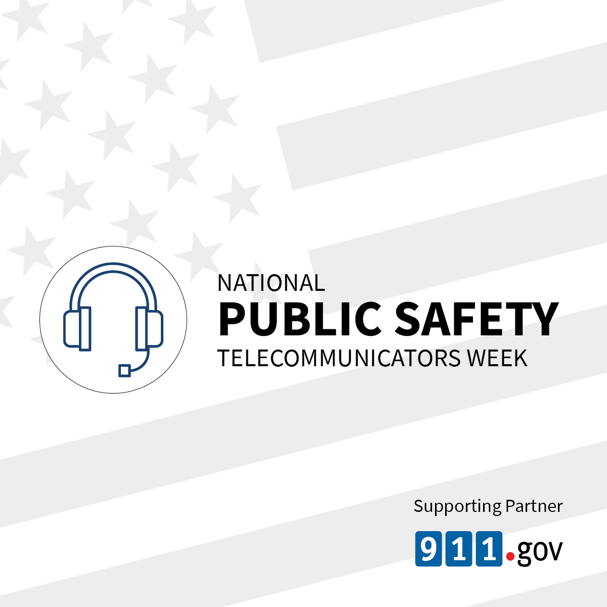
- Share Stories of 911 Telecommunicators for NPSTW
Honor the impact of your fellow #publicsafetytelecommunicators on the 911 Telecommunicator Tree of Life. Share their inspiring life-changing stories during National Public Safety Telecommunicators Week and watch the tree “grow!” #911TOL #NPSTW
