Hawaii
As FEMA and federal partners continue to support state and local governments, as residents should continue following the direction of local officials and not let their guard down. Tropical Storm Lane continues to weaken, but rain continue along some of the islands.

 | SAFETY AND SECURITY
 | Three FEMA Urban Search and Rescue teams and four Law Enforcement Quick Response Teams are deployed in Hawaii to support potential lifesaving operations.
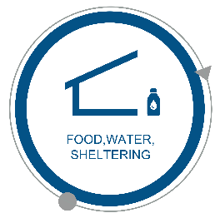 | FOOD, WATER, SHELTERING
 | FEMA maintains strategically located facilities on the islands to provide the state with supplies as needed and requested. Approximately 1,000 people stayed in shelters Friday night as the numbers continue to decrease.
 | HEALTH AND MEDICAL
Dialysis Centers with on-site generators have been identified on each island.
Two U.S. Department of Health and Human Services Disaster Medical Assistance teams are deployed to Hawaii.
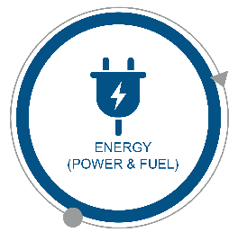 | ENERGY (POWER & FUEL)
Generators have been shipped and ready to use.
U.S. Department of Energy and U.S. Army Corps of Engineers are deployed to support temporary power and energy systems.

 | COMMUNICATIONS
 | Mobile Emergency Communications Assets are deployed to support the state. FEMA staff are pre-positioned to ensure operational communications are resilient for effective coordination at all five county operation centers.
 | TRANSPORTATION
Sea ports are beginning to reopen as assessments continue.
All major airports are open at this time, and airlines are beginning to schedule flights.
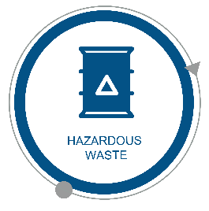 | HAZARDOUS WASTE
 | The U.S. Army Corps of Engineers is deployed to support planning for debris or waste removal.

