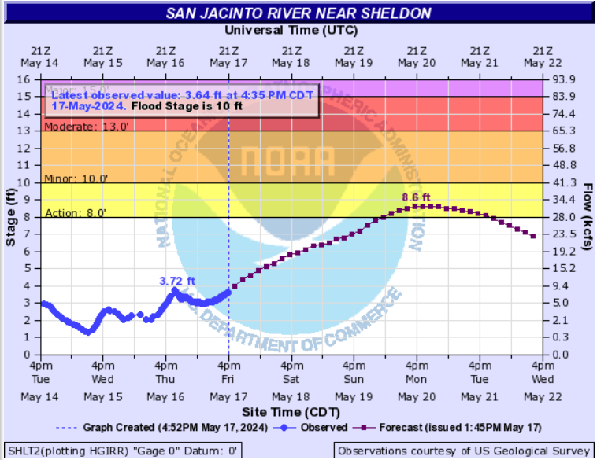

<https://water.weather.gov/ahps2/hydrograph.php?wfo=hgx&gage=shlt2&hydro_type=0>