The following information pertains specifically to Software Vendors/Providers
Valid Unit of Measure (UOM) and Valid Manifest Unit Code must be transmitted with the ANSI 12 - 309 and UNEDIFACT -- CUSCAR

ANSI 12
N10 record -
N1007 segment – Valid Weight Unit Codes
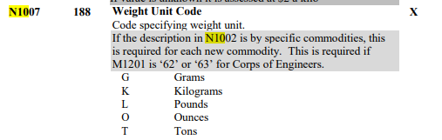

N1010 segment – Valid Manifest Unit Codes can be found in CAMIR Appendix N
ACE Ocean CAMIR Appendix N Manifest Units of Measurement | U.S. Customs and Border Protection (cbp.gov)

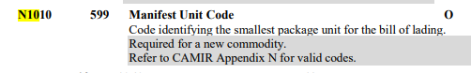

UNEDIFACT – CUSCAR

PAC record – C202 Package Type Description Code

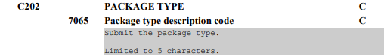
MEA record – 6411 Measurement unit code
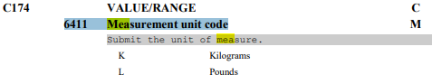

Valid Hazmat Codes must be transmitted via ANSI 12 - 309 and UNEDIFACT - CUSCAR

ANSI X12
H1 Hazardous Material

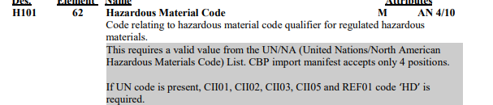

UNEDIFACT - CUSCAR
FTX Record - 4451 TEXT SUBJECT CODE QUALIFIER “AAC”
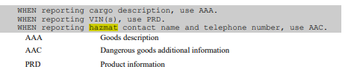

C108 TEXT LITERAL “UNDG” is transmitted
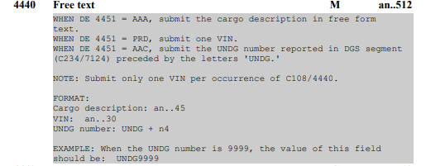

Valid Schedule K Port Codes must be transmitted via ANSI 12 – 309 and UNEDIFACT – CUSCAR

ANSI 12
M11 - Manifest Bill of Lading Details
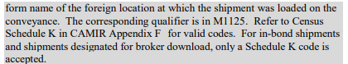
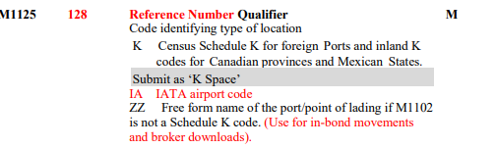

UNEDIFACT - CUSCAR
LOC Record
3227 LOCATION FUNCTION CODE QUALIFIER
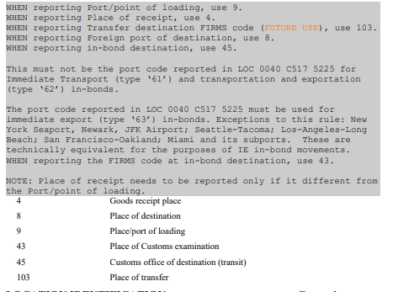
C517 LOCATION IDENTIFICATION
