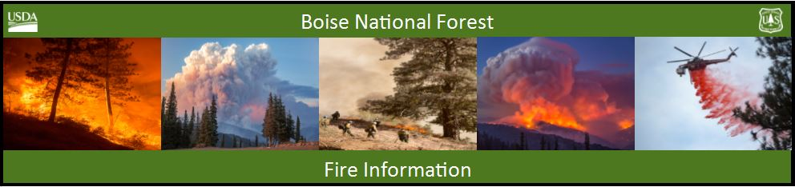

Bearskin Fire Update –Friday, September 8, 2017
Bearskin Fire Information: https://inciweb.nwcg.gov/incident/5536/
Boise National Forest Fire Information: 208-373-4105

Acres: 25,808 Acres Containment: 0 percent Personnel: 94
Resources assigned: 2 crews, 1 helicopter, 9 engines, 2 water tenders, 1 NIMO Team

BOISE, Idaho, September 8, 2017 – Yesterday fire activity picked up on the west side and the fire spread north near Deadwood mine and Pilgrim Summit area. Fire activity on the east side was minimal.

Fire crews are continuing with chipping and thinning along NFS road 555 and 579. Chipping is also taking place in the area of the Deadwood Outfitters. Sprinklers are being used in the Deadwood Outfitters area and Bureau of Reclamation facilities to keep vegetation wet.

The red flag warning expired Thursday night. A moist southerly airflow moving over the burn site Friday will bring a chance of thunderstorms that may last through Saturday afternoon. Erratic winds and gusts could accompany the thunderstorms. The smoke inversion layer hovering over the area for the last few days will begin lifting in the early afternoon Friday.

The Bearskin Fire area closure has been put in place for public safety and includes the Deadwood Reservoir area and all the campgrounds and trails in the vicinity. The NFS road 582 through Bear Valley remains open except between the junctions of NFS roads 545 and 515 which is closed for construction (see paragraph below). The Closure Order and maps are available at: https://www.fs.usda.gov/alerts/boise/alerts-notices or at Forest Service Ranger Stations, and are posted on bulletin boards along roads into the Bear Valley area.

A segment of the Clear Creek Road (NFS road 582) is closed from above the junction with NFS road 545 (Long Creek Summer Homes) north to the junction with NFS road 515 for culvert construction work for six weeks. Forest visitors will need to plan their trips accordingly; maps are available at Lowman Ranger Station (208-259-3361) and on the Boise National Forest website: https://www.fs.usda.gov/main/boise/maps-pubs

Stage 1 fire restrictions are in effect on public and private lands under fire protection of the Boise National Forest, Boise BLM and State of Idaho. Campfires are only permitted in developed recreation sites with an agency approved metal fire ring. Smoking is allowed in a cleared area of at least 3 feet in diameter, in a vehicle or in a developed recreation site. For specific information visit: http://www.idahofireinfo.com/p/fire-restrictions.html

###

