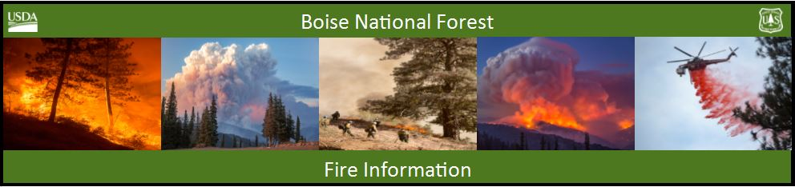

Bearskin Fire Update –Monday, September 4, 2017
Bearskin Fire Information: https://inciweb.nwcg.gov/incident/5536/
Boise National Forest Fire Information: 208-373-4105

Acres: 19,283 Acres Containment: 0 percent Personnel: 105
Resources assigned: 4 crews, 1 helicopter, 4 engines, 2 water tenders, 1 NIMO Team
Bearskin Fire Expected to Move Southwest toward Deadwood Reservoir

BOISE, Idaho, September 4, 2017 – With a red flag warning still in place, hot, dry and unstable weather continues to dominate our area. Winds out of the north-northeast are expected for Monday through Tuesday morning, which will move the Bearskin Fire to the south and southwest in the direction of Deadwood Reservoir.
Bearskin Fire grew to over 19,000 acres once the inversion created by heavy smoke lifted from the fire area late yesterday morning. An increase in fire activity is expected again today when the inversion lifts. Heavy fuels remain between the fire and Deadwood Reservoir, created by stands of insect-killed dead and down lodgepole pine and subalpine fir. There has also been limited spread into the Frank Church River of No Return Wilderness on the northeast side of the fire.
Crews continue to treat fuels north of Deadwood Reservoir along the NFS roads 555 (Scout Mountain/Deadwood Road) and 579 (Landmark to Stanley Road). A feller-buncher is being used to clip dead trees along the road corridor, then crews are bucking the felled trees and running them through a chipper. This reduces the heavy fuel load and enhances the capability of the roads to act as a fuel breaks. Incident Commander Mike Quesinberry says that the immediate goal of the firefighting efforts is to keep the fire on the east side of the Deadwood River drainage.
To protect public and firefighter safety, the Bearskin Fire area closure has been expanded to include the Deadwood Reservoir area and all the campgrounds in the vicinity. The NFS road 582 through Bear Valley remains open at this time. The Closure Order and maps are available at: https://www.fs.usda.gov/alerts/boise/alerts-notices or at Forest Service Ranger Stations, and posted on bulletin boards on roads into the Bear Valley area.

The Clear Creek Road (NFS Road 582 at MP 4.5) will also be closed from above the Long Creek Summer Homes north to the junction with the NFS Road 545/515 for six weeks beginning this evening for construction work. Forest visitors will need to plan their trips accordingly; maps are available at Lowman Ranger Station (208-259-3361) and on the Boise National Forest website: https://www.fs.usda.gov/main/boise/maps-pubs
As the hunting season gets underway coupled with extreme potential for fire growth, visitors are reminded that Stage 1 fire restrictions are in effect on public and private lands under fire protection of the Boise National Forest, Boise BLM and State of Idaho. Under Stage 1 restrictions, campfires are only permitted in developed recreation sites with an agency provided structure. Smoking is allowed in a cleared area of at least 3 feet in diameter, in a vehicle or in a developed recreation site. For specific information visit: http://www.idahofireinfo.com/p/fire-restrictions.html

