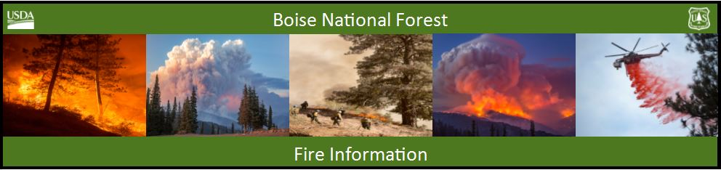

Bearskin Fire Update –Sunday, September 3, 2017
Bearskin Fire Information: https://inciweb.nwcg.gov/incident/5536/
Boise National Forest Fire Information: 208-373-4105

Acres: 15,278 Acres Containment: 0 percent Personnel: 118
Resources assigned: 4 crews, 1 helicopter, 4 engines, 2 water tenders, 1 NIMO Team
Red flag warning in effect Sunday and Monday for Boise National Forest

BOISE, Idaho, September 3, 2017 – A red flag warning goes into effect this morning and will be in place through Monday evening. National fire preparedness remains at its highest level – Level 5. A red flag warning means that conditions are ideal for wildfire starts and rapid spread.
Bearskin Fire growth was moderated yesterday by a heavy smoke inversion. The fire is still mapped at
15,278 acres. As the inversion lifts, fire activity will increase with moderate rates of spread in the heavy fuels created by stands of dead and down lodgepole pine and subalpine fir.
Crews remain focused on reducing fuels around the Deadwood Outfitters and the Elk Creek Guard station. Bureau of Reclamation infrastructure at Deadwood Reservoir is being assessed for fire preparedness.
A strong ridge of high pressure over southwest Idaho and southeast Oregon brings continued hot, dry and unstable conditions through Tuesday. The Haines Index, used to predict potential for large fire growth is expected to be at level 6 (highest ranking) Sunday and Monday. Relative humidity will drop to single digits, and winds will be light. No showers or thunderstorms are expected until Thursday.
With extreme potential for fire growth, forest visitors are reminded that Stage 1 fire restrictions are in effect on public and private lands under fire protection of the Boise National Forest, Boise BLM and State of Idaho. Under Stage 1 restrictions, campfires are only permitted in developed recreation sites with an agency provided structure. Smoking is allowed in a cleared area of at least 3 feet in diameter, in a vehicle or in a developed recreation site. For specific information visit: (www.idahofireinfo.com/p/fire-restrictions.html)
To protect public and firefighter safety, the Bearskin Fire area closure has been expanded to include the Deadwood Reservoir area and all the campgrounds in the vicinity. The NFS Road 582 through Bear Valley remains open at this time. The Closure Order and maps are available at: https://www.fs.usda.gov/alerts/boise/alerts-notices or at Forest Service Ranger Stations, and posted on bulletin boards on roads into the Bear Valley area.
Forest Service personnel are stationed at the primary road junctions to assist the public in understanding the closures and ensuring their safety. Any campers who had belongings moved from the closure area should contact the Lowman Ranger Station (208-259-3361).

