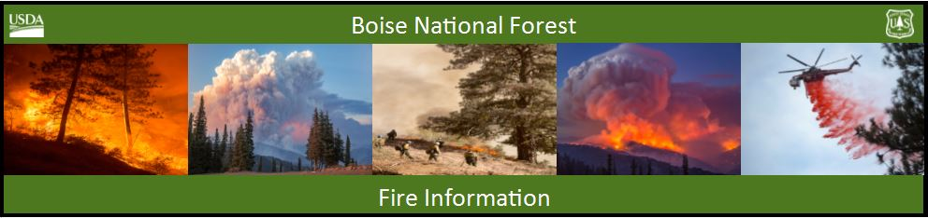

Bearskin Fire Update – Saturday, September 2, 2017
Bearskin Fire Information: https://inciweb.nwcg.gov/incident/5536/
Boise National Forest Fire Information: 208-373-4105

Acres: 15,278 Acres Containment: 0 percent Personnel: 115
Resources assigned: 3 crews, 1 helicopter, 4 engines, 1 NIMO Team
Public and firefighter safety primary in Bearskin Fire suppression efforts

BOISE, Idaho, September 2, 2017 – With hot and dry weather conditions, the Bearskin Fire continues to grow. The 15, 278 acre fire is burning about 4 miles northeast of Deadwood Reservoir. A National Incident Management Organization (NIMO) team is now in command of the fire.
The Bearskin Fire is actively burning in steep and rough terrain, making short crown runs, spreading upslope and spotting ahead of the fire. Slopes are covered with highly flammable stands of lodgepole pine and sub-alpine fir heavy with dead and down trees. The fire is surrounded by old burn scars, and firefighters hope to use those to their advantage in suppressing this fire.
To protect public and firefighter safety, the Bearskin Fire area closure has been expanded to include the Deadwood Reservoir area and all the campgrounds in the vicinity. The NFS Road 582 through Bear Valley remains open at this time. Maps of the closure area are available on the Boise National Forest website (https://www.fs.usda.gov/alerts/boise/alerts-notices), Forest Service Ranger Stations, and posted on bulletin boards on roads into the Bear Valley area.
Forest Service personnel are stationed at the primary road junctions to assist the public in understanding the closures and ensuring their safety. Any campers who had belongings moved from the closure area should contact the Lowman Ranger Station (208-259-3361).
With fire crews and other resources scarce, firefighters are concentrating on point protection for local infrastructure. Fuels reduction work is underway around the Deadwood Outfitters facilities, Bearskin and Idaho Power weather stations, Deer Flat campground and the Elk Creek Guard station. Fire preparedness is being assessed for Deadwood Reservoir facilities. Crews are improving contingency fire lines on the National Forest System Road 579 (Landmark to Stanley Road) and NFS Road 555 (Deadwood Road). Other Boise National Forest personnel are on hand to ensure that our fish, water and archeologic resources are also being protected.
As a hotter, drier weather pattern establishes over the west, temperatures will remain in the 90s. This will increase the chance of large fire growth, with a Haines Index level expected to rise to 6 by Sunday.
Nationally, the Fire Preparedness Level is still at PL5. About 1.5 million acres are burning across the U.S., with a wildfire year to date total of almost 7. 4 million acres. https://www.nifc.gov/nicc/sitreprt.pdf
The 10 acre Boulder Fire, burning 4 miles of Idaho City, is expected to be fully contained today. A Temporary Flight Restriction is in place. http://tfr.faa.gov/tfr_map_ims/html/ew/scale7/tile_14_18.html
The Forest has Stage 1 Fire Restrictions are in place. For fire restriction details visit: www.idahofireinfo.com/p/fire-restrictions.html.

