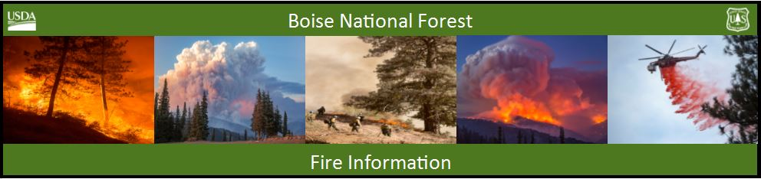

Bearskin Fire Update – Wednesday, August 31, 2017
Bearskin Fire Information: https://inciweb.nwcg.gov/incident/5536/
Boise National Forest Fire Information: 208-373-4105

Acres: 11,305 Acres Containment: 0 percent Personnel: 110
Resources assigned: 3 crews, 1 helicopter, 3 engines, 1 NIMO Team

Bearskin Fire increases and moves to the northeast

BOISE, Idaho, August 31, 2017 – The Bearskin fire driven by winds ahead of afternoon thunderstorms has increased to 11,305 acres. The fire crossed National Forest System road 579 near the Deer Flat Campground and into the Little Beaver Creek drainage.
NFS road 579 is closed from the junction of NFS 582 to the junction of NFS road 555. The current area closure will be expanded for firefighter and public safety before the holiday weekend. For closure information: https://www.fs.usda.gov/alerts/boise/alerts-notices
Fire behavior was active with short crown runs through lodgepole pine and sub-alpine fir stands which are 50 percent dead and down from past insect infestations. The fire is actively spreading upslope and continues to spot ahead of the fire. Fire spread is expect to move northeast following the perimeter of the 2010 Little Beaver Complex and into the Deadwood River drainage
Weather is predicted to be cooler and drier with 20 mph wind gusts from the Northwest with increasing temperatures into triple digits through the Labor Day weekend.
Firefighters are providing point protection around threatened infrastructure which includes removing vegetation around Idaho Power’s weather station, Deadwood Outfitters facilities, Deer Flat campground and the Elk Creek Guard station.
Nationally, 59 large fires are burning and preparedness level remains at PL 5. At PL 5 firefighting resources are heavily committed and the potential for more large fires is high and expected to remain high throughout the west.
A new lightning caused fire started on the Idaho City Ranger District late yesterday afternoon. The Boulder Fire is 10 acres and located 4 miles northeast of Idaho City in the headwaters of Boulder Creek. Crews are making good progress with the help of aviation resources. Off road vehicles users should avoid riding on National Forest System roads 357 and 329 which could lead them directly into the fire. A Temporary Flight Restriction is in place for the area. http://tfr.faa.gov/tfr_map_ims/html/ew/scale7/tile_14_18.html
The Forest has Stage 1 Fire Restrictions are in place. For fire restriction details visit: www.idahofireinfo.com/p/fire-restrictions.html
For current closure information: https://www.fs.usda.gov/alerts/boise/alerts-notices

