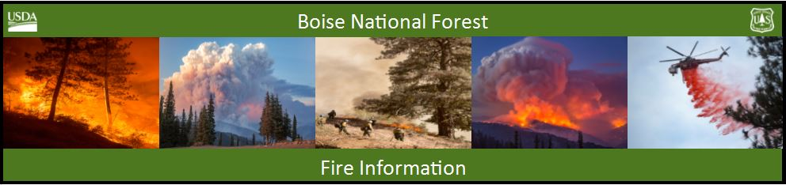

Bearskin Fire Update – Wednesday, August 30, 2017
Bearskin Fire Information: https://inciweb.nwcg.gov/incident/5536/
Boise National Forest Fire Information: 208-373-4105

Acres: 6014 Acres Containment: 0 percent Personnel: 102
Resources assigned: 3 crews, 1 helicopters, 3 engines, 1 NIMO Team

High pressure system pushes Bearskin Fire west

BOISE, Idaho, August 30, 2017 – The lightning caused Bearskin fire is over 6,000 acres. Yesterday winds from a high pressure system pushed the fire toward the west into more dead, bug kill and down lodgepole pine and sub-alpine fire. An expanded area closure is in place for public and firefighter safety.

A fire weather watch is in effect this afternoon and continuing through the evening. An upper level trough is approaching bringing a chance of showers and thunderstorms with maximum temperatures of 79 degrees. The best chance for showers is expected in the afternoon and may last into the evening. A trough will move through Thursday, pushing a cold, dry front in the afternoon and winds are predicted to increase from the west to northwest Thursday afternoon and evening.

Firefighters continue to remove vegetation from National Forest System roads 579 and 563 to slow the progress of the fire. The fire is burning near Chinook salmon, steelhead and bull trout spawning areas and crews are using screens to draft water for firefighting efforts.

With the Labor Day weekend ahead, public land visitors are reminded that Stage 1 Fire Restrictions are in place. For fire restriction details visit: www.idahofireinfo.com/p/fire-restrictions.html

Nationally, 60 large fires are burning and preparedness level remains at PL 5. At PL 5 firefighting resources are heavily committed and the potential for more large fires is high and expected to remain high throughout the west.

Quisenberry’s National Incident Management Organization (NIMO) Team from Atlanta, Georgia, is assisting the Forest with developing a strategy to manage and suppress the fire burning in bug kill and snags. NIMO teams increase capacity in the same manner as Incident Management Teams in providing additional support with planning, decision processes and efficient and effective agency support.

For current closure information: https://www.fs.usda.gov/alerts/boise/alerts-notices

