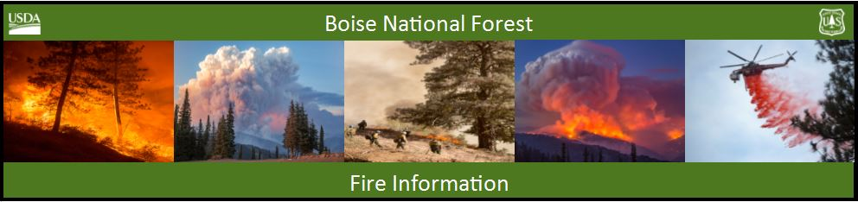

Bearskin Fire Update – Tuesday, August 29, 2017
Bearskin Fire Information: https://inciweb.nwcg.gov/incident/5536/
Boise National Forest Fire Information: 208-373-4105

Acres: 5,000 Acres Containment: 0 percent Personnel: 102
Resources assigned: 3 crews, 1 helicopters, 3 engines

BOISE, Idaho, August 29, 2017 – The approximate 5000-acre lightning caused Bearskin fire continues to grow as it consumes dead, bug kill and down lodgepole pine and sub-alpine fir. The area closure has been increased for public safety. Fire officials expect the closure area to expand if the fire continues to spread.

Weather conditions are hot with a chance of afternoon showers and thunderstorms predicted this week, with maximum temperatures of 90 degree. A fire weather watch in effect lightning beginning Wednesday afternoon and continuing through evening.

The fire is actively burning through dead and down fuel along with tree torching, uphill runs and short-range spotting into flammable forested stands.

With the national preparedness at level 5, full suppression strategies of confine and point protection are being used to address concerns for firefighter safety and the lack of available resources.
- Confinement strategies restrict the wildfire within determined boundaries with a combination of direct and indirect actions applied. For example: removing vegetation along the roadside to slow the fire progress enough for firefighters to directly engage.
- Point protection is a response strategy to protect specific assets or highly valued resources such as remote weather stations, radio towers and structures.

With limited resources and Incident Management Teams (IMTs) committed to large fires across the west, a National Incident Management Organization (NIMO) Team has arrived to assist the Forest’s Type 3 IMT with developing a strategy to manage and suppress the fire. NIMO teams increase capacity in the same manner as IMTs and provide additional support in planning, decision processes and efficient and effective agency support.

For current closure information: https://www.fs.usda.gov/alerts/boise/alerts-notices

