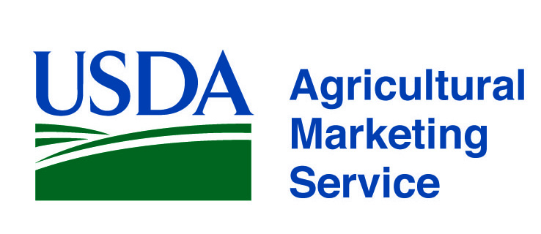 |  | www.ams.usda.gov/scp  FVInfo@usda.gov  Tel. (202) 720-4722
Program and Division | Services | Contact
AMS Specialty Crops Program,  Office of the Deputy Administrator  www.ams.usda.gov/scp | USDA AMS Specialty Crops Program (SCP) provides customized solutions to enhance the competitive, efficient, and transparent marketing of all specialty crops. We offer a full range of quality assurance and audit verification services providing our clients and their customers with confidence that products are grown, processed, and distributed under the most favorable conditions. Our range of services include:  - Commodity Standards Development  - Grading, Inspection, Certification and Audit-based Verification Services  - Commodity and other technical training programs  - Domestic and International Commodity Market News  - Marketing Order and Agreements administration  - Research and Promotion program administration  - Economic Analysis  - Liaison Activity related to FDA & FSMA (Produce Safety) | Ken Petersen, Acting Deputy Administrator (202) 720-9897  ken.petersen@usda.gov  Heather Pichelman, Associate Deputy  Administrator, (202) 720-9915 heather.pichelman@usda.gov  Audrey Draper, USDA-FDA Liaison  (202) 720-9136 audrey.draper@usda.gov
Specialty Crops Inspection Division    www.ams.usda.gov/scihome | Serving the fresh, processed and fresh-cut fruit and vegetable and specialty crops industry with…  - Fresh and processed produce quality/condition inspection and grading services.  - Audit-based solutions to enhance food safety practices, including Good Agricultural Practices (GAP) for growers, Good Handling Practices (GHP) for packers, shippers, and distributors of fresh produce and Good Manufacturing Practices (GMP) for processor’s and fresh-cut operations.  - Quality Monitoring Program (QMP) to verify supplier contract compliance.  - Identity Preservation Program for clients with unique, value-added products.  - U.S. Grade Standards & Industry Training. | Nathaniel “Chip” Taylor  Division Director  (202) 720-2333  nathaniel.taylor@usda.gov  Ryan Wilson  Associate Director, Inspection Services  (559) 753-0070  ryan.wilson@usda.gov  Jessica Brower  Associate Director, Inspection Operations  (863) 450-7022  jessica.brower@usda.gov
Promotion and Economics Division  www.ams.usda.gov/fvpromotion | Providing oversight of nationwide research and promotion programs for fruit, vegetable, and specialty crop industries. Authorized by federal legislation, Research and Promotion Programs are designed to strengthen the position of the industry in the marketplace and to maintain and expand domestic and foreign markets. The programs are all fully funded by industry assessments. Analysis of economic information and programs related to federal food purchase and other programs. | Heather Pichelman, Acting Division Director  (202) 690-1172  heather.pichelman@usda.gov

www.ams.usda.gov/scp
FVInfo@usda.gov
Tel. (202) 720-4722
Program and Division | Services | Contact
Market News Division    www.marketnews.usda.gov/portal/fv | Collects, analyzes and disseminates detailed price, demand, movement and other market information for over 787 specialty crop commodities including fruits, vegetables, nuts, ornamental crops, honey and beekeeping, and apple juice concentrate.  - Prices collected at shipping point, wholesale and retail levels.  - Movement data collected at domestic production areas, harbors and air- ports of entry, and border crossings for imports.  - Truck rate report provides a unique snapshot of shipping costs and the availability of trucks from production and import areas to major cities.  - Retail data captured nationwide on weekly advertised specials.  - Organic price and movement data collected on hundreds of commodities at all three market levels.  - COMING SOON --- My Market News Enhanced access to data with advanced tools such as API. | Terry Long, Division Director (202) 720-2175  terry.long@usda.gov  John Okoniewski, Deputy Director 202 720-9932  john.okoniewski@usda.gov  Jeff Main, National Market Reporting Technology Manager (509) 575-8903  jeff.main@usda.gov
Marketing Order and Agreement Division  www.ams.usda.gov/rules-regulations/moa/fv | MOAD helps fruit, vegetable and specialty crop producers and handlers achieve marketing success through industry driven programs.  Marketing orders and agreements improve returns to producers by:  - Targeting domestic and foreign markets with industry-funded promotion, advertising, publicity, production and marketing research, and market information programs;  - Maintaining a consistently high quality of produce on the market;  - Standardizing packages and containers;  - Regulating the flow of product to market. | Heather Pichelman, Acting Division Director  (202) 690-1172  Heather.pichelman@usda.gov  William Richmond  Chief, USDA Hemp Production Program (202) 720-9921 william.richmond@usda.gov
AMS Commodity Procurement Division  www.ams.usda.gov/fvprocurement | Purchase of U.S. produced fresh and processed products from approved vendors for distribution to schools, food banks, Tribal organizations and other USDA programs. | David Tuckwiller  Deputy Administrator (202) 720-2784 david.tuckwiller@usda.gov  Christopher Purdy  Associate Deputy Administrator (202) 720-3209 christopher.purdy@usda.gov  Andrea Lang, Small Business Coordinator (202) 720-4237 newvendor@usda.gov

