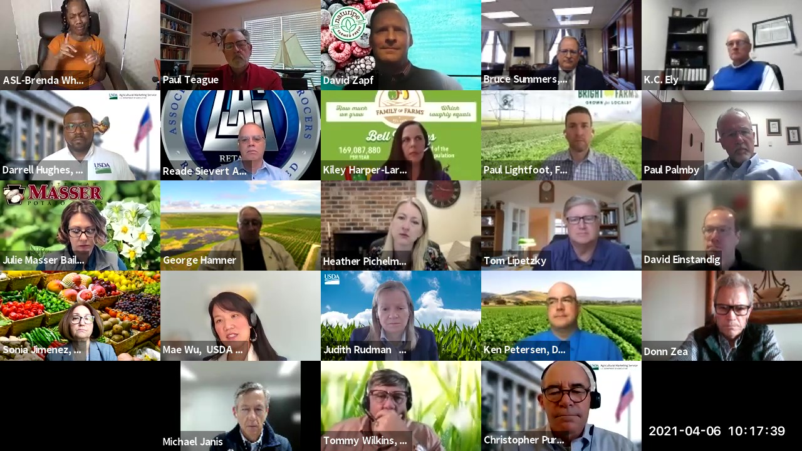
Fruit and Vegetable Industry Stakeholders to Collaborate, Share Ideas on Optimizing USDA Programs, Services
Photo Caption: Ag industry representatives discuss a range of services and programs with USDA officials.

The USDA Fruit and Vegetable Industry Advisory Committee (FVIAC) convened on April 6, 2021 to begin examining a full spectrum of fruit and vegetable industry issues.
This was the FVIAC’s first meeting since the start of the COVID-19 pandemic and was designed for industry representatives recently appointed to the FVIAC to hear from USDA on topics ranging from food safety and climate change to grants and conservation opportunities.
The virtual meeting kicked off with joint opening remarks from Bruce Summers, Administrator of the Agricultural Marketing Service (AMS), and Mae Wu, the Deputy Under Secretary of the Marketing and Regulatory Programs (MRP). AMS ensures the FVIAC is administered according to the Federal Advisory Committee Act.
In remarks, Ms. Wu spoke on USDA goals, such as optimizing outreach “to rural, remote and underserved communities, and we need to offer foods that are more focused on nutritional needs.” From a policy perspective, the USDA intends to “help the faltering rural economy and climate crisis by putting rural America at the heart of solutions for climate change so we can prioritize economic development and growth in rural America, and put the U.S. in a leadership position on climate change mitigation,” Ms. Wu said.
AMS Administrator, Mr. Summers, expressed appreciation to FVIAC representatives for their volunteering to serve on the committee, and went on to explain ways the AMS helped support the industry through the pandemic which include but is not limited to the launch of the free USDA PACA mobile app and improvements to food safety verification programs.
Regarding next steps, FVIAC Chair Paul Lightfoot explained, over the next several weeks, the FVIAC would discuss via email or reconvene via a series of administrative meetings where they could determine their subcommittees to begin exploring ways USDA programs and services could be tailored to better meet the needs of the U.S. produce industry.
The FVIAC also intends to find ways to collaborate with other USDA advisory bodies. FVIAC recommendations are submitted to the Secretary of Agriculture.
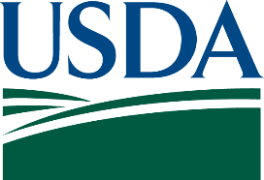
View the FVIAC Representative Factsheet
Learn more about the FVIAC

