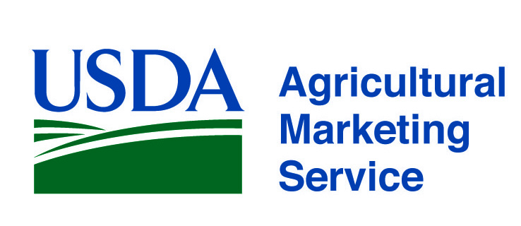 |  | www.ams.usda.gov/scp  FVInfo@usda.gov  Tel. (202) 720-4722
Program and Division | Services | Contact
AMS Specialty Crops Program,  Office of the Deputy Administrator  www.ams.usda.gov/scp | USDA AMS Specialty Crops Program (SCP) provides customized solutions to enhance the competitive, efficient, and transparent marketing of all specialty crops. We offer a full range of quality assurance and audit verification services providing our clients and their customers with confidence that products are grown, processed, and distributed under the most favorable conditions. Our range of services include:  - Commodity Standards Development  - Grading, Inspection, Certification and Audit-based Verification Services  - Commodity and other technical training programs  - Domestic and International Commodity Market News  - Marketing Order and Agreements administration  - Research and Promotion program administration  - Economic Analysis  - Perishable Agricultural Commodities Act (PACA) enforcement | Sonia Jimenez, Deputy Administrator, (202) 720-4722 sonia.jimenez@ams.usda.gov  Charles Stephens, Associate Deputy  Administrator, (202) 720-6394 charlesd.stephens@ams.usda.gov  Lorenzo Tribbett, Associate Deputy Administrator (Acting), (202) 720-3209  lorenzo.tribbett@ams.usda.gov  Leanne Skelton, Liaison to FDA on FSMA  (202) 720-0982 leanne.skelton@ams.usda.gov
Specialty Crops Inspection Division  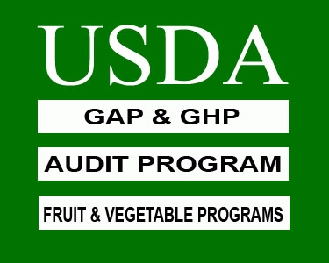  www.ams.usda.gov/scihome | Serving the fresh, processed and fresh-cut fruit and vegetable and specialty crops industry with…  - Fresh and processed produce quality/condition inspection and grading services.  - Audit-based solutions to enhance food safety practices, including Good Agricultural Practices (GAP) for growers, Good Handling Practices (GHP) for packers, shippers, and distributors of fresh produce and Good Manufacturing Practices (GMP) for processor’s and fresh-cut operations.  - Quality Monitoring Program (QMP) to verify supplier contract compliance.  - Identity Preservation Program for clients with unique, value-added products.  - U.S. Grade Standards & Industry Training.  - The Qualified through Verification (QTV) program to assist food processors enhance their hazard analysis critical control point (HACCP) plan to ensure its continual effectiveness through unannounced audits. | Nathaniel “Chip” Taylor  Division Director (Acting),  (202) 720-2333 nathaniel.taylor@ams.usda.gov  Randle Macon, Associate Director,  (202) 720-4693 randle.macon@ams.usda.gov
Promotion and Economics Division  www.ams.usda.gov/fvpromotion | Administration of nationwide research and promotion programs for the fresh fruit and vegetable industry. Authorized by federal legislation, Research and Promotion Programs are designed to strengthen the position of the industry in the marketplace and to maintain and expand domestic and foreign markets. The programs are all fully funded by industry assessments. Analysis of economic information and programs related to federal food purchase and other programs. | Heather Pichelman, Division Director (202) 720-9915, heather.pichelman@ams.usda.gov  Patricia Petrella, Deputy Director  (202) 260-9496, patricia.petrella@ams.usda.gov

www.ams.usda.gov/scp
FVInfo@usda.gov
Tel. (202) 720-4722
Program and Division | Services | Contact
Market News Division    www.marketnews.usda.gov/portal/fv | Collects and disseminates detailed price, demand and movement information for over 412 specialty crop commodities including fruits, vegetables, nuts, ornamental crops, honey and beekeeping, and apple juice concentrate.  - Prices collected at shipping point, wholesale and retail levels,  - Organic prices collected on 144 commodities at all market levels,  - Movement data collected at domestic production areas, sea and air ports of entry, and border crossings.  - Truck rate report provides a unique snapshot of shipping costs from production areas to major cities.  - COMING SOON --- Market Analysis and Reporting Services (MARS) going live by January, 2019! | Terry Long, Division Director (202) 720-2175  terry.long@ams.usda.gov  John Okoniewski, Deputy Director 202 720-9932  john.okoniewski@ams.usda.gov  Jeff Main, National Market Reporting Technology Manager (509) 575-8903  jeff.main@ams.usda.gov
Marketing Order and Agreement Division  www.ams.usda.gov/rules-regulations/moa/fv | MOAD helps fruit, vegetable and specialty crop producers and handlers achieve marketing success through industry driven programs.  Marketing orders and agreements improve returns to producers by:  - Targeting domestic and foreign markets with industry-funded promotion, advertising, publicity, production and marketing research, and market information programs;  - Maintaining a consistently high quality of produce on the market;  - Standardizing packages and containers;  - Regulating the flow of product to market. | Patty Bennett, Division Director  (202) 720-2491  patty.bennett@ams.usda.gov  Andrew Hatch, Deputy Division Director (Acting) (202) 720-6862  andrew.hatch@ams.usda.gov  Richard Lower, Assistant to the Director (202) 720-2020 richard.lower@ams.usda.gov
AMS Commodity Procurement Division  www.ams.usda.gov/fvprocurement | Purchase of fresh and processed products from approved vendors for school lunch and other government food programs. | David Tuckwiller, Deputy Administrator (202) 720-2784, david.tuckwiller@ams.usda.gov  Christopher Purdy,  Associate Deputy Administrator (202) 720-3209  christopher.purdy@ams.usda.gov  Andrea Lang, Small Business Coordinator (202) 720-4237 newvendor@ams.usda.gov

