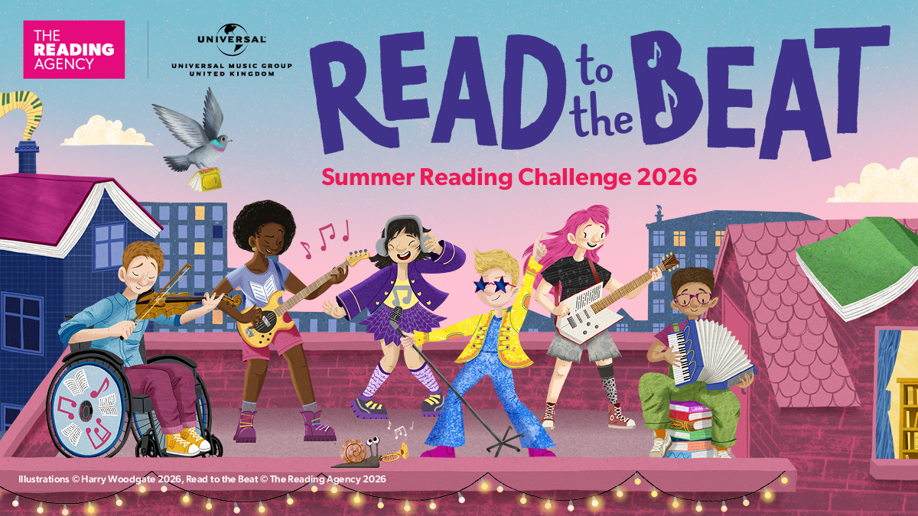
Pick up the tempo and Read to the Beat at a library near you
West Sussex Library Service's popular Summer Reading Challenge is back!
This year’s theme is Read to the Beat, a celebration of reading and music.
Pre-registration is open from Monday 15 June and the Summer Reading Challenge starts in your local West Sussex library on Saturday 4 July, running until Saturday 12 September. It’s free for families to take part and a great way to encourage reading for pleasure during the long summer holiday. The Challenge also helps younger children get ready for school.
The Main Challenge is aimed at children aged 4-11 years, whilst under-4s can take part in the Mini Challenge. Every child taking part in the Challenge will receive a special Summer Reading Challenge edition of Storytime Magazine and a bookmark when they start, collecting stickers and fun rewards throughout.

Children will have access to a wide range of books – both physical and downloadable! They will have all summer to enjoy books and achieve personalised reading goals, returning to the library several times to discuss the books they have been reading or sharing with Summer Reading Challenge Volunteers.

Families can find out more and sign up at libraries.westsussex.gov.uk/src.

Please share this information with families and encourage them to come to the library and join Read to the Beat this summer.

