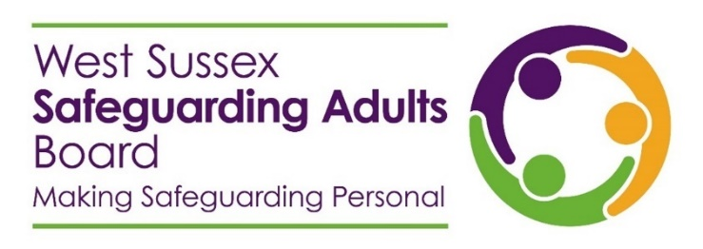
Partnership release
West Sussex Safeguarding Adults Board launch their new learning pathway
The West Sussex Safeguarding Adults Board has launched their new learning pathway; a self-directed study pathway for staff across the partnership, which brings together learning resources produced by the Board.
Split into three parts, the pathway presents online learning resources according to essential adult safeguarding information, resources to develop skills, and guidance to enhance practice. The pathway is intended to be a useful resource for staff at all levels, either as an introduction to adult safeguarding, or as a comprehensive refresher.
Alongside the pathway, the Board has produced a workbook, to support learners through their journey. The workbook guides the learner through each digital resource, providing opportunities for reflection, further reading, and discussion points for agencies.
Annie Callanan, Independent Chair, has said of the new initiative:
“I am excited to endorse the launch of our new learning pathway. It has been developed from bringing together what we know our valued partnership staff need to be aware of and understand to improve safeguarding practice and achieve the best possible outcomes. The pathway is based on learning from our Safeguarding Adults Reviews, audits, and surveys which have told us of where improvements are needed. The pathway draws on our existing and new learning resources and more easily helps to guide you through safeguarding learning and practice. We hope you find the pathway helpful and very much welcome your feedback on it, so please do get in touch to let us know what you think.”
Tom Weedon, Community Operations Manager, West Sussex County Council, said:
“I’m delighted to see the launch of this new learning pathway. This is a significant and comprehensive resource to help people explore, develop, refresh and reflect on their safeguarding knowledge and skills. Making Safeguarding Personal is everyone’s responsibility and the learning pathway is an invaluable tool to reinforce and expand our understanding of adult safeguarding practice with a pathway through the vast range of resources and learning available to us all.”
Staff from across the health and social care sector, including staff from the voluntary, private, and independent sector, can access the new learning pathway and accompanying workbook on the West Sussex Safeguarding Adults Board website.
END
The West Sussex Safeguarding Adults Board is a multi-agency partnership, which oversees and coordinates the effectiveness of adult safeguarding across West Sussex.

