Invitation for Community Partners
The Multi-Agency Approach to Fire Risk Awareness Training
The aim for this session is Fire Risk Awareness, Intervention, and Exploring the Multi-Agency
Person-Centred Approach towards strength-based practice.
SPEAKERS FROM FIRE – HEALTH - HOUSING – SOCIAL CARE
West Sussex Fire & Rescue Service (WSFRS) focus on targeting the most vulnerable people in the community who are at the highest risk of harm in the home. We seek to ensure access to our fire safety advice by promoting the prevention activity of the ‘Safe and Well Visit’. These home fire safety visits are an effective way of improving safety within people's homes. West Sussex Fire and Rescue Service personnel will carry out the visits, giving advice and fitting smoke alarms/equipment where appropriate. A Safe and Well Visit is not an inspection but a conversation, for which the person must give consent for a visit to be carried out. These conversations often lead to advice and signposting to connect with other community partners in housing, health, mental health, social care, community safety including blue light services, care and support agencies.

Working in partnership to deliver Safe and Well in collaboration with other agencies our partners can identify and refer individuals in their caseloads and patient lists, ensuring we can collaborate to make every contact count and provide advice and guidance on not only fire risk, but link with other associated health and wellbeing support for those most vulnerable people in our community. Safe and Well visits are carried out with a person-centred approach. This means risk reduction measures can be identified and delivered jointly around the risk, health, behaviour, and social care needs of the person, taking into account their thoughts and wishes.

We know through our incident data that certain groups are more likely to have an accidental fire in their home and they include people such as those living with Dementia, those with mobility restrictions, or mental health issues. Risk increases with age, decrease in mobility, sedentary smoking, and medical equipment such as oxygen, emollient creams, and air flow mattresses. There are however a number of other groups we aim to identify and contact who aren’t necessarily recognised as being at a higher risk of fire, but they may not be accessing our services such as Safe and Well Visits or Reporting Fires because of other barriers which may be language, perceived prejudice, and other societal factors such as Domestic Abuse or Modern Slavery. Equality of access means actively seeking to engage these groups who may be unaware or choosing not to access services from us and other public sector providers.

In the Multi-Agency Fire Risk Awareness session, we also tackle concerns for self-neglect in the home, where a person may be living in an unsafe or unsanitary environment, or perhaps their home is showing signs of disrepair or energy inefficiency. We provide an introduction to the Safe & Habitable Homes Framework providing guidance on managing hoarding, Diogenes, and disrepair.

Home Fire Risk Statistics tell us that the most everyday activities in people’s home are the most common cause of fire incidents. Cooking alone makes up for nearly half of the fire calls we attend, followed by electrical faults and overload. Not having a free smoke detector can increase the risk of a dwelling fire fatality to be up to 10 times more likely. Awareness and changing behaviour is a life-saver along with early response and joint action.
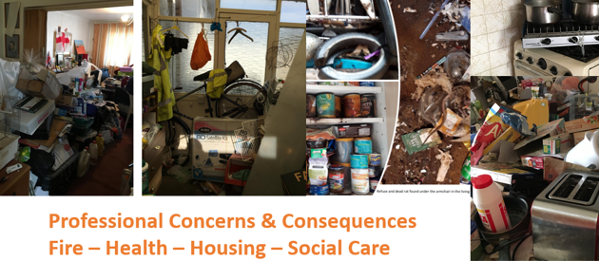

This training is on MS Teams and is free to attend – email to sign up Frs.Cptt@westsussex.gov.uk

