Education Prospectus 2024 – 25

We offer a range of courses to support education & training needs for both clinical, working in health and social care settings.
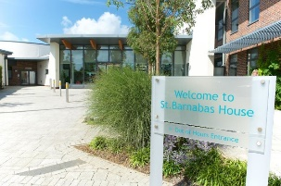

Barnabas Hospices
St Barnabas House
Education Dept
Titnore Lane
Worthing
West Sussex BN12 6NZ

To join us at one of our education events, please visit www.stbh.org.uk/education and complete an online booking. Alternatively, telephone 01903 706356 or email education@stbh,org.uk to speak to one of our team.

- Tuesday 18th March 25 – Intermediate Communication Skills at 09:30 – 16:30 NOW FULLY FUNDED

We are currently developing our new Clinical Education Prospectus for May – December 2025, with many FULLY FUNDED courses. If you would like more information about this, keep an eye out on our website (above). Also, you can join our mailing list by emailing (again, above) to request this.

