Education Prospectus 2024 – 25

We offer a range of courses to support education & training needs for both clinical, working in health and social care settings.
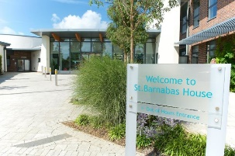

Barnabas Hospices
St Barnabas House
Education Dept
Titnore Lane
Worthing
West Sussex BN12 6NZ

To join us at one of our education events, please visit www.stbh.org.uk/education and complete an online booking. Alternatively, telephone 01903 706356 or email education@stbh,org.uk to speak to one of our team.

- Thursday 30th January 25 – Introduction to Palliative Care at 09:30 – 13:00 £10
- Tuesday 4th February 25 – Advance Care Planning including introduction to ReSPECT at 09:30 – 13:00 £50
- Tuesday 11th February 25 – Palliative Care Emergencies at 09:30 – 13:00 £50
- Tuesday 18th February 25 – Symptom Management in the Last Days of Life at 09:30 – 13:00 FULLY FUNDED
- Tuesday 18th March 25 – Intermediate Communication Skills at 09:30 – 16:30 £100

