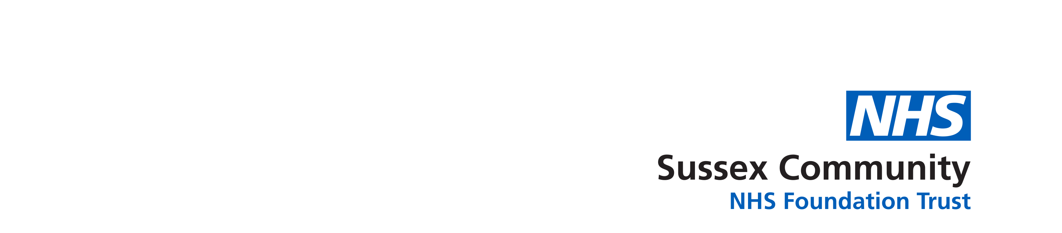
08
Fall

ReSPECT Level 2 Authorship sessions for staff external to SCFT
This session is aimed at Senior Registered Nurses, Paramedics, Medical Staff or AHPs who will facilitate and document ReSPECT conversations and clinical recommendations.
All sessions are from 09.00hrs to 12.00 midday via the Teams App (this will need to be downloaded beforehand and accessed on a computer, not a phone as the link won’t work.)
Please use your work email to book and access the session.
To book, please email sc-tr.ourpeoplesgateway@nhs.net
with the following details:

*Name:
*Email:
*Place of Work:
*Job Role:
*Date you want to attend (selected from dates below):
2025
January 21st February 11th March 25th

You will then be forwarded the Teams Link to the email you have supplied above.

Please note failure to supply all the requested information as above * will result in your booking not being complete.
It is important that the link is not shared between staff as staff may not receive all the required joining instructions and pre-learning. To book a place please follow the process for booking as above
Key learning outcomes:
• explain the background to and purpose of the ReSPECT process
• describe the sequence involved in the ReSPECT process
• demonstrate how to achieve appropriate shared decision-making
• show how to record recommendations that are easy to understand
• describe capacity law and the role of a legal proxy
• explain practical matters (e.g. how to document, share & when to review)

Following completion of the course it is expected that the candidate will be supported to reach self-assessed competency in facilitating ReSPECT conversations, electronically completing, and sharing ReSPECT plans by their own organization /locally. A ReSPECT resource pack is emailed to participants post completion to support this.

